**121M1INISTRY OF EDUCATION AND TRAINING VIET NAM**

**FPT UNIVERSITY**

Capstone Project Document

[Low or High Price]

|  |  |  |
| --- | --- | --- |
| Low or High Price **Group** | | |
| **Group Members** | Lê Duy Công | SE03929 |
| Nguyễn Thanh Tùng | SE03924 |
| Trần Hồng Quân | SE03733 |
| Nguyễn Văn Vinh | SE03927 |
| Phong | SE03697 |
| **Supervisor** | **Mr. Trần Bình Dương** | |
| **Capstone Project code** | LowHoPe | |

Ha Noi 5th Oct, 2017

**Acknowledge**

We specially thank to Mr. Tran Binh Duong, our supervisor, for  
his support throughout this project. His instruction and  
motivation has been lessons for us not only about technique,   
but also about how to work as a team in a real project.  
We also thank to our families and friends. Their encouragement  
has helped us to overcome many pressure to complete our  
product

**Record of change**

*A - Added M - Modified D - Deleted

|  |  |  |  |  |
| --- | --- | --- | --- | --- |
| Effective Date | Changed Items | A* M, D | Change Description | New Version |
| 12/09/2017 | Project document | A | Initiate version | 1.0 |
|  |  |  |  |  |
|  |  |  |  |  |
|  |  |  |  |  |
|  |  |  |  |  |
|  |  |  |  |  |
|  |  |  |  |  |
|  |  |  |  |  |
|  |  |  |  |  |
|  |  |  |  |  |
|  |  |  |  |  |
|  |  |  |  |  |
|  |  |  |  |  |
|  |  |  |  |  |
|  |  |  |  |  |
|  |  |  |  |  |
|  |  |  |  |  |
|  |  |  |  |  |
|  |  |  |  |  |

Table of Contents

CHAPTER 1: INTRODUCTION 8

**1.1** **Purpose** 8

**1.2** **Project Information** 8

**1.2.1** **Project members** 9

**1.2.2** **Problems** 9

**1.2.3** **Solution** 10

**1.2.4** **Existed system** 10

**1.2.5** **Our Proposal** 12

CHAPTER 2: SOFTWARE PROJECT MANAGEMENT PLAN 14

**2.1. Purpose** 14

**2.2. Problem Definition** 14

**2.2.1. Name of this Capstone Project** 14

**2.2.2. Problem Abstraction** 14

**2.2.3. Project Overview.** 15

**2.3. Project organization** 17

**2.3.1 Software Process Model** 17

**2.3.2 Software Process Model** 18

**2.3.3 Tool and Techniques.** 21

**2.4. Schedules** 22

**2.5. Communication Management** 22

**2.5.1 Stakeholders and Contacts** 22

**2.5.2 Communication Management Approach.** 23

**2.5.3 Communication Requirements** 23

**2.5.4 Communication Method and Technologies** 23

**2.5.5 Communication Matrix** 24

**2.6. Risk Management** 25

**2.6.1 Risk Management Approach** 25

**2.6.2 Risk Identification** 26

**2.6.3 Risk Qualification and Prioritization** 26

**2.6.4 Risk Monitoring** 26

**2.6.4 Risk Register** 27

**2.7. Quality Management** 30

**2.7.1 Quality Management Overview** 30

Definitions and Acronyms

| Acronym | Definition | Note |
| --- | --- | --- |
| BA | Business Analyst |  |
| Analysis and Design | A&D |  |
| Front-end Design | FD |  |
| LowHoPe | Low or High Price |  |
| BU | Business Unit |  |
| CI | Configuration Item |  |
| CM | Configuration Management |  |
| CSCI | Computer Software Configuration Items |  |
| DEV | Developer |  |
| DB | Database |  |
| MM | Meeting Minute |  |
| PC | Person in charge |  |
| PM | Project Manager |  |
| PMP | Project Management Plan |  |
| PTL | Project Technical Leader |  |
| QA | Quality Assurance Officer |  |
| SDD | Software Detail Design |  |
| SUM | Software User Manual |  |
| SRS | Software Requirement Specification |  |
| W# | Week# |  |
| WR | Weekly Report |  |
| TP | Test Plan |  |
| TC | Test Case |  |
|  |  |  |

# CHAPTER 1: INTRODUCTION

## **Purpose**

The purpose of this chapter is to provide an overview of Low or High Price web service and why we chose it. And we also show Idea, solution, some basic functions in this project. Besides, we have some benefit and limitation in the project. Thereby, we will research orientation of future.

## **Project Information**

|  |  |
| --- | --- |
| **Project name** | Low or High Price |
| **Project code** | LowHoPe |
| **Project type** | Website |
| **Project manager** | Trần Hồng Quân |
| **Start** | 6ᵗʰ 10, 2017 |

### **Project members**

* **Supervisor:**

|  |  |  |
| --- | --- | --- |
| Full name | E-mail | Title |
| Trần Bình Dương | **duongtb@fpt.edu.vn** | **Lecturer** |

* **Team Members:**

|  |  |  |  |
| --- | --- | --- | --- |
| Full name | Roll Number | E-mail | Phone |
| **Tran Hong Quan** | SE03733 | Quanthse03733@fpt.edu.vn | 0962575594 |
| **Le Duy Cong** | SE03929 | Congldse03929@fpt.edu.vn |  |
| **Nguyen Thanh Tung** | SE03924 | Dungltse02166@fpt.edu.vn | 0974803191 |
| **Nguyen Van Vinh** | SE03927 | Vinhnvse03427@fpt.edu.vn |  |
| **Nguyen Huy Phong** |  |  |  |

### **Problems**

In the world today, the electronic money market is growing. There are many types of electronic money but the most popular nowadays is bitcoin. However, there are few websites can provide exact information about bitcoin prices; bitcoin prediction market and exchange or bitcoin game. So if there is a secure website can provide bitcoin prediction market and exchange, it is really convenient for people who are interested in electronic money.

### **Solution**

Creating a website provides exact information about market fluctuates bitcoin prices every day. Creating bitcoin prediction game and exchange market bitcoin. So the website will help people who are interested in bitcoin.

### **Existed system**

**SIMPLEFX**

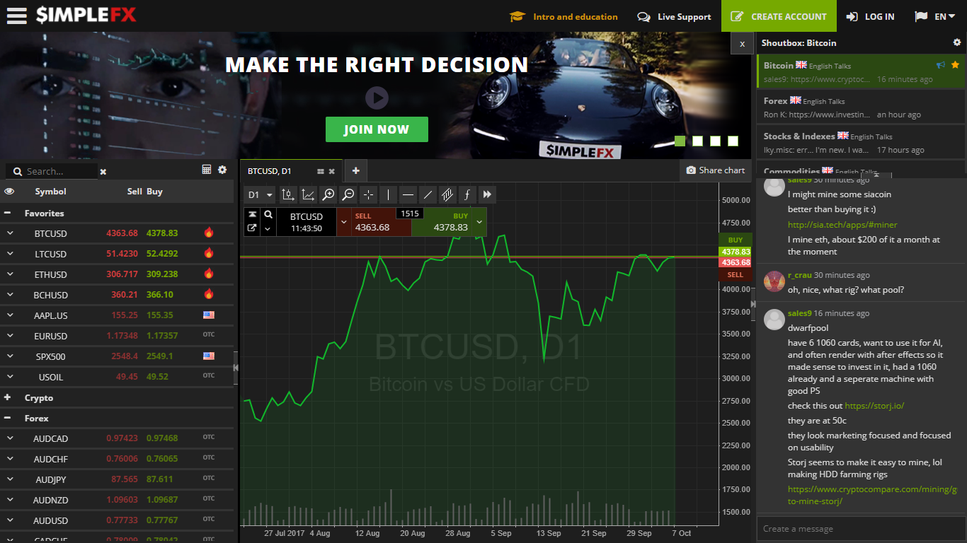

*Figure 1:simplefx*

This website introduces advanced trading methods with the Electronic money especially bitcoin. The website allow users to exchange (buy or sell) electronic money, update bitcoin prices fluctuate all of time.

* Advantages:
* Power supply electronic money prices superfast.
* Support almost needed features about exchange electronic money.
* Update exact electronic money prices all of time.
* Disadvantages:
* Complicate.

**IQOPTION**

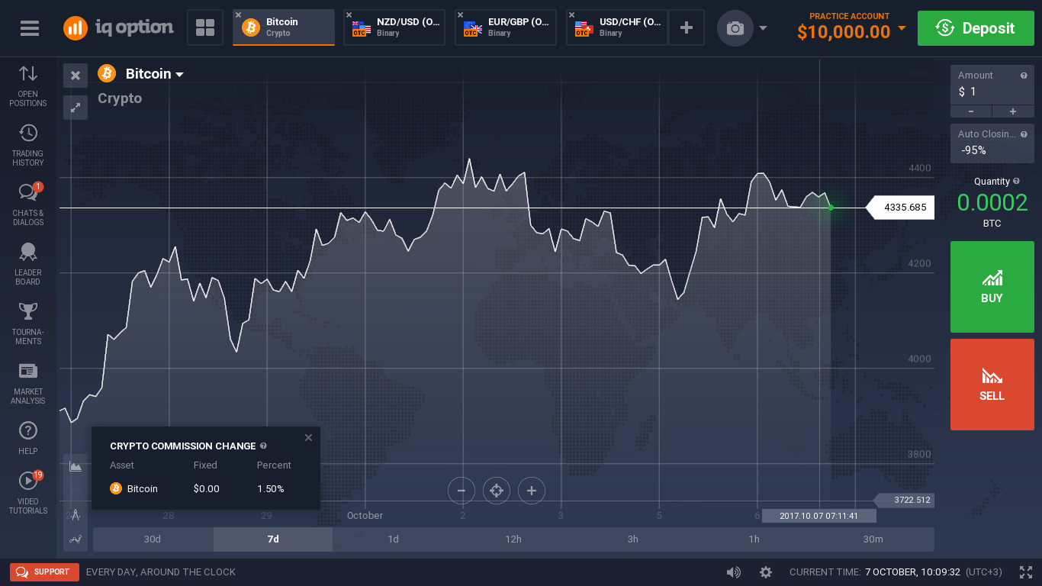

*Figure 2: IQoption*

This website introduces advanced trading methods with the Electronic money especially bitcoin. The website allow users to exchange (buy or sell) electronic money, update bitcoin prices fluctuate all of time.

* Advantages:
* Power supply electronic money prices superfast.
* Support almost needed features about exchange electronic money.
* Update exact electronic money prices all of time.
* Disadvantages:
* Complicate.

### **Our Proposal**

We will develop a single website bitcoin prediction market and betting exchange that support people who are interested in bitcoin.

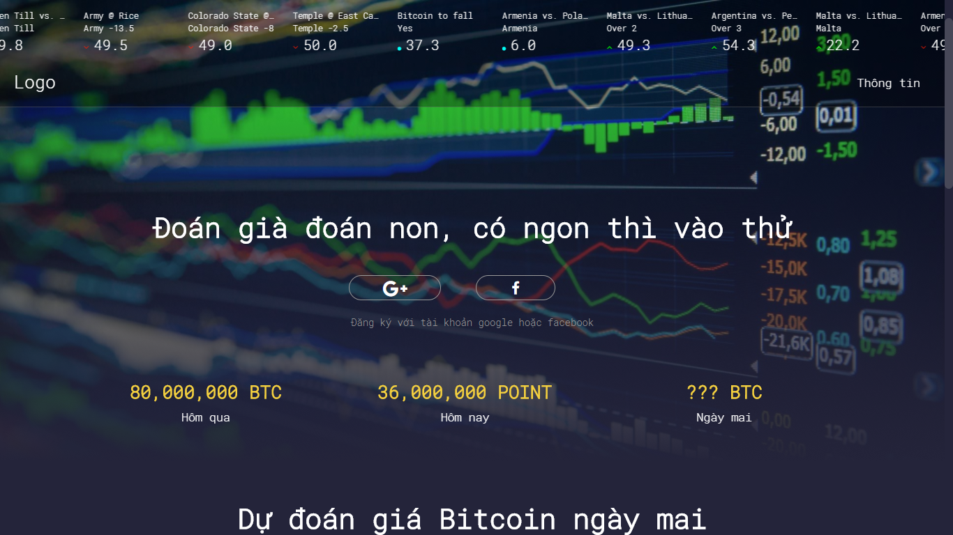

*Figure 3: LowHope*

* We create some game bitcoin leading betting exchange. The essence of a betting exchange is that you don’t bet against the house, you bet against other users. The web will have the below main functions:
* Daily game
  + Game is played everyday
  + Each day is played only once
  + Allows to roll dice, players choose parity. Winning 50 points.
* Yes or No game.
  + Allows the player to make bitcoin betting game, exchange with answer Yes - No.
* Multiple choice game.
  + Allows players to create multiple choice games about bitcoin prices.
* Our website sets up the market, matches bettors each other and pays out the winner with the losers’ money.
* We update exact bitcoin prices all of time. It is showed by chart.
* Most of our predictions are on bitcoin prices betting.
* Our combination of a 0% fee policy, automation friendly UI (API) are the foundation of our outstanding odds.
* No account needed.

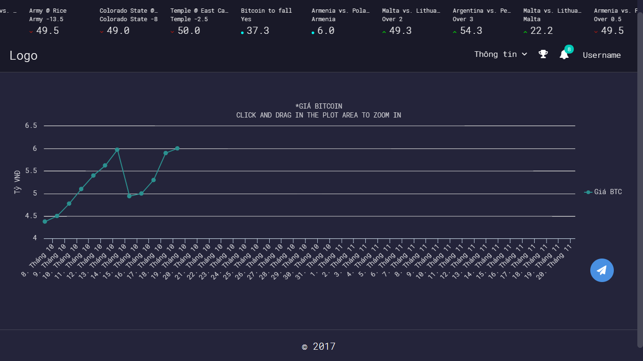

*Figure 4: chart of Lowhope*

# CHAPTER 2: SOFTWARE PROJECT MANAGEMENT PLAN

## **2.1. Purpose**

In this chapter, we will talk about the specific roles of the project team members. Plan and organize the project, the responsibilities of the members in each task. Project team members use this document to know their responsibilities and actions in the project.

## **2.2. Problem Definition**

### **2.2.1. Name of this Capstone Project**

* **Capstone project name:** Low or High Price**.**
* **Abbreviation:** LowHPe

### **2.2.2. Problem Abstraction**

The electronic money market is growing and the most popular nowadays is bitcoin. There are a lot of websites where providing bitcoin prediction market and exchange (buy or sell) but there are very few game website about bitcoin for people who want to play some bitcoin betting games.

People feel bored with bitcoin websites that only bitcoin exchange (buy or sell).

Everyone has difficulty finding a bitcoin website that can update exact information about bitcoin prices and be entertained to play bitcoin betting games.

### **2.2.3. Project Overview.**

#### **2.2.3.1. Project description.**

In this project, we will develop a website with PHP to provide bitcoin prediction market and exchange through bitcoin betting game. User login website to play bitcoin betting game and update exact information about bitcoin prices all of times. This website will help user feel interesting. It is not boring as other bitcoin website. The website will be designed to be easy to use.

#### **2.2.3.2 Scope.**

This project covers all processes, from planning, requirement, specification, design, development, to testing. Project team will develop a website with PHP for user to play bitcoin betting game and update exact information about bitcoin prices, and manage data collection from API under JSON format.

* **Functional requirements:**

The website allows user to play bitcoin betting game and update exact information about bitcoin prices and this website developed for Admins and Manager of website. Admins and Manager can login, logout, manage their profile, manage database (upload, edit, delete). Admin can add/edit/delete manager’s account.

* **Non-functional requirements:**

The website must be design for user’s convenience and easy to use. Interface design should be beautiful looking and easy to understand.

#### **2.2.3.3. Standard Objectives.**

* This project must be finished no later than 15/12/2017.
* The final Application covers 100% of requirements.
* The 5 team members give best effort to complete the project.

#### **2.2.3.4. Development Environment.**

|  |  |  |
| --- | --- | --- |
|  | **Minimum Requirements** | **Recommended** |
| Internet Connection | Cable, Wi-Fi (4 Mbps) | Cable, Wi-Fi (8 Mbps) |
| Computer Processor | Intel® Core™ i3 | Intel® Core™ i7 |
| Computer Memory | 4 GB | 8 GB or more |
| Web Browser | Google Chrome 60.0.3112.101 | Google Chrome 60.0.3112.101 or higher |
| Operation System | Window 7 | Window 10 |

#### **2.2.3.5. Milestones and Deliverables.**

##### **2.2.3.5.1 Milestones**

|  |  |  |  |
| --- | --- | --- | --- |
| **No.** | **Task** | **Start date** | **End date** |
|  | Approve Project’s initial idea | 06/09/2017 | 06/09/2017 |
|  | Create and submit report 1: Introduction | 12/09/2017 | 16/09/2017 |
|  | Create and submit report 1: Management Plan ver1.0 | 22/09/2017 | 26/09/2017 |
|  |  |  |  |

##### **2.2.3.5.2 Deliverables**

|  |  |  |  |  |  |
| --- | --- | --- | --- | --- | --- |
| **No** | **Deliverables** | **Format** | **Delivery date** | **Verified by** | **Deliver Medium** |
|  | Approve Project’s initial idea |  |  |  |  |

## **2.3. Project organization**

### **2.3.1 Software Process Model**

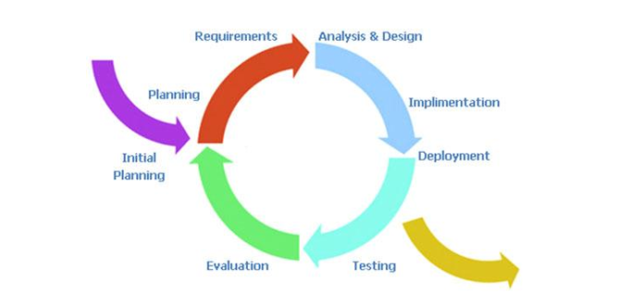

Figure 5: Iterative and Incremental process model

The reason why the project team chooses Iterative & Incremental software process model:

* This model is more flexible – less costly to change scope and requirements.
* Reduce the risk of delay due to the important work done first.
* Establish a good relationship between users and developers. Project team will always communicate with users to obtain information to meet the needs of users.
* Repetition of the phases can be built so that the system really met the demand of users
* Through every iterative, we can control scope and requirements, flexibly update or even change things if we think it will help us to have a better product.
* It is easy to manage risk by dividing it into pieces and solve it as quick as possible in each iterative.

### **2.3.2 Software Process Model**

#### **2.3.2.1 Team organization structure**

**Tran Binh Duong**

**Supervisor**

**Tran Hong Quan**

**PM**

**Nguyen Thanh Tung**

**Nguyen Van Vinh**

**Nguyen Thanh Tung**

**Le Duy Cong**

**Tran Hong Quan**

**QA & Project Document Leader**

**Backend Leader**

**Testing Leader**

**FD Leader**

**Analysis&design Leader**

**Le Huy Phong**

**Tester #2**

**DEV #2**

**DEV #1**

**Tester #1**

**Nguyen Van Vinh**

**Tran Hong Quan**

**Member #1**

**Designer #1**

**Le Huy Phong**

**Tran Hong Quan**

**Le Huy Phong**

**Nguyen Van Vinh**

**Le Duy Cong**

**Member #2**

**Nguyen Thanh Tung**

**Member #3**

**Le Duy Cong**

**Tester #3**

#### **2.3.2.2. Roles and responsibilities**

|  |  |  |  |
| --- | --- | --- | --- |
| **Role** | **Full Name** | | **Quality Responsibility** |
| **Instructor** | Project Management | | - Give instruction for project team.  - Verify deliverables.  - Supervise project team’s status |
| **PM** | Tran Hong Quan | | Have overall responsibility of the project  - Create project plan  - Assign task to team members  - Tracking team member’s work  - Report work status to the instructor |
| * **Requirement analysis team** | | | |
| **QA & Project Document Leader** | Nguyen Thanh Tung | | - Write document report for project.  - Complete SRS Document and submit to PM.  - Manage the Quality Assurance function  - Audits and approve project deliverables from QA perspective. Review plans and deliverables for compliance with applicable standards. Provides guidance and assistance on process matters |
| * **Analysis and Design Team** | | | |
| **Analysis**  **&design leader** | Tran Hong Quan | - Analysis and design ideas for website and database | |
| **Member #1** | Nguyen Van Vinh | - Support in design for website | |
| **Member #2** | Le Duy Cong | - Support in design for database | |
| **Member #3** | Nguyen Thanh Tung | - Drawing details for entity relationship diagram. | |
| * **Front-end Design Team** | | | |
| **Front-end Design leader** | Nguyen Van Vinh | - Design interface for website screen. | |
| **Designer #2** | Le Huy Phong | - Support in design interface for screen website | |
| * **Backend Team** | | | |
| **Backend leader** | Le Duy Cong | - Train other member of website with PHP development  - Create coding convention  - Decide technique and tools to be used  - Develop Website with PHP  - Create SDD  - Code backend | |
| **DEV #1** | Tran Hong Quan | -Code all function for Manager page and Admin page. | |
| **DEV #2** | Le Huy Phong | - Research on web data collection from API under JSON format.  -Code for automatic processing of game.  - Code for web data collection from API under JSON format.  - Code for database related functions of website with php. | |
| * **Test Team** | | | |
| **Testing Leader** | Nguyen Thanh Tung | - Responsible for test execution, including test set-up and test run, evaluation of test run and error recovery, defect logging and test results recording.  - Create test plan  - Create test cases  - Execute text cases  - Report test result | |
| **Tester #1** | Tran Hong Quan | - Create test cases  - Execute text cases | |
| **Tester #2** | Nguyen Van Vinh | - Create test cases  - Execute text cases | |
| **Tester #3** | Le Huy Phong | - Create test cases  - Execute text cases | |
| **Tester #4** | Le Duy Cong | - Create test cases  - Execute text cases | |

### **2.3.3 Tool and Techniques.**

#### **2.3.3.1. Hardware**

- Personal computer for coding and testing with minimum configuration of 2GB RAM, 80GB of hard disk, Intel core 2 Duo.

- Internet network connection.

#### **2.3.3.2. Software**

|  |  |  |
| --- | --- | --- |
| Category | Software Name | Version |
| Operating system | Microsoft Windows 10 | Professional |
| Office tools | Microsoft word | 2013 |
| Microsoft Excel | 2013 |
| Microsoft Power Point | 2013 |
| Management Tool | Microsoft Project | 2013 |
| Trello |  |
| upm.fpt.edu.vn |  |
| Design Tool | Astah professional | 6.9.0 |
| Adobe ILLustrator | 2017 |
| Mysql Workbench | 6.3.9 |
| Development Tools | Sublime Text 3 |  |
| Visual Studio | 2015 |
| Database Tools | SQLite manager | 0.8.1 |
| MySQL |  |
| Source code management Tool | Github.com |  |
| Programming Language | C#, JavaScript, HTML, CSS, Bootstrap, PHP. |  |

## **2.4. Schedules**

## **2.5. Communication Management**

### **2.5.1 Stakeholders and Contacts**

|  |  |  |  |
| --- | --- | --- | --- |
| **Name** | **Title** | **Role** | **Contacts** |
| Tran Binh Duong | Mr. | Supervisor | [duongtb@fpt.edu.vn](mailto:duongtb@fpt.edu.vn)  (84) 936-168-165 |
| Tran Hong Quan | Mr. | PM | quanthse@fpt.edu.vn |
| Le Duy Cong | Mr. | Developer |  |
| Nguyen Van Vinh | Mr. | Front-end design |  |
| Le Huy Phong | Mr. | Developer |  |
| Nguyen Thanh Tung | Mr. | QA ; SRS Document and Tester |  |

### **2.5.2 Communication Management Approach.**

Project team communicate frequently to ensure the progress of each member’s work. Project manager report to the Supervisor frequently and honestly so that the Supervisor can track the team’s work and give support/advice as need.

All request for change or proposal of new ideal must be discussed in team. If project team agree to change, project team must then discuss with the Supervisor. Once the change is approved, project manager will update the plan and to project team and Supervisor.

The communications requirements are documented in the Communications Matrix of This document. The Communications matrix will be used as guide for what/when/how/who/whom to communicate throughout the project.

### **2.5.3 Communication Requirements**

The project manager will communicate with the Supervisor in order to determine his preferred frequency and time of communication.

As all project team members still take part in classes while doing project, project manager should communicate to understand their schedule, and therefore specify appropriate communication plan for the team.

### **2.5.4 Communication Method and Technologies**

- Create a Facebook private group for team member to discuss and share informal information and activity. This would be a place for member to communicate freely, and therefore would help in strengthen relationship between members.

- Use Google docs to share documents.

- Public weekly reports of team members in Google docs to keep them writing report. This will help project manager in tracking work of team members, and also help team member understand progress of the others.

- Update Work schedule before weekly meeting with Supervisor.

### **2.5.5 Communication Matrix**

|  |  |  |  |  |  |  |  |
| --- | --- | --- | --- | --- | --- | --- | --- |
| **Communication Type** | **Objective** | **Medium** | **Frequency** | **Audience** | **Owner** | **Deliverable** | **Format** |
| Kickoff Meeting | Discuss and agree on project objective, and scope | - Face to face | Once (At the start of the project) | - Instructor - Project Team | Project Manager | Meeting Minutes | - Soft copies on  Microsoft Word |
| Project Team Meeting | Review status of the project. Discuss solutions for any raised issues. Assign tasks for team members | - Face to face - Email - Conversation (Skype) | 3 times per week, base on personal schedule. | - Project Team | Project Manager | - Project schedule - Assigned tasks | - Soft copies on  Microsoft Word - Assigned tasks on  Trello |
| Project Plan Meeting | Discuss and planning project process | - Face to face - Email - Conversation (Skype) | As needed | - Project Team | Project Manager | - Meeting Minutes - Project Management Plan | - Soft copies on  Microsoft Word - WBS on Microsoft Project |
| Architecture Design Meeting | Review prototype Discuss, contribute and review System Architecture Design | - Face to face - Email | As needed | - Project Team | Backend Leader | - Meeting Minutes - System Architecture Design Document | - Soft copies on Microsoft Word - System Architecture Design on Astah |
| GUI Design Meeting | Discuss, contribute and review GUI Design | - Face to face - Email | As needed | - Project Team | Front-end Leader | - Meeting Minutes - GUI Design -Document | - Soft copies on Microsoft Word - GUI Design on Photoshop |
| Database Design Meeting | Discuss, contribute and review Database Design | - Face to face | As needed | - Project Team | Backend Leader | - Meeting Minutes - Database Design | - Soft copies on Microsoft Word |
| Automatic processing Meeting | Discuss solutions for any raised issues, contribute | -Face to face | As needed | Project team  Instructor | Backend Leader | - Meeting Minutes.  -Automatic processing. | - Soft copies on  Microsoft Word |
| Test Plan Meeting | Discuss, and review Test Plan | -Face to face | As needed | Project team | -Front-end leader  -Backend leader | -Meeting Minutes  -Test Plan | -Soft copies on  Microsoft Word |

|  |  |  |  |  |  |  |  |
| --- | --- | --- | --- | --- | --- | --- | --- |
| Bug Report | Report found bugs to team members and assign fix tasks. | - Face to face - Email | As needed | - Project Team | Test Leader | - Bug Report | - Soft copies on Microsoft Excel |
| Personal Weekly Report | Report task status (what is done, what will be done next week, any issue) of personal work. | - Email - Google driver | Every Friday | - Project team | Project Manager | - Personal Weekly Report | - Soft copies on Microsoft Excel |
| Project team weekly report | Report task status (what is done, what will be done next week, any issue) | - Email | Every Saturday | - Instructor | Project manager | - Weekly report | - Soft copies on Microsoft word |
| Meeting with Instructor | Report project status of team’s work to instructor.  Get advices for project from instructor. | - Face to face - Email | Every Monday | - Instructor - Project Team | Project Manager | - Meeting Minutes - Team Weekly Report | - Soft copies on Microsoft Word |
| Unexpected Issue | Find a solution for any unexpected raised issues. | - Face to face - Conversation (Skype) - Facebook private group | As needed | - Instructor - Project Team | Project Manager | - Meeting Minutes | - Soft copies on Microsoft Word |

## **2.6. Risk Management**

### **2.6.1 Risk Management Approach**

The approach to manage risks for this project is the process by which project team identifies and ranks the various risks. The most likely and high impact risks will be added to the risk register and will be delivered to all team members, to ensure that every member perceive of these potential risks. Project manager must pay attention to all items in risk register during project and take appropriate action when a risk triggered. Upon the completion of the project, project manager will analyze each risk as well as the management process. Base on this analysis, project manager will identify any improvements that can be made to risk management process, and capture these improvements as a part of lessons learned.

### **2.6.2 Risk Identification**

Risk identification will be conducted in the first project team meeting. The method used by project team to identify risk will be brainstorming. Every team member raise their idea about any risk that might happen. PM will note down team member’s idea. There must be no judgment or bias during brainstorming. When there is no other idea, project team will review all risks that have been note down. Risks that is almost unlikely to happen will be erased. Risks with high impact or most likely to happen will be kept. There should be no more than 10 risks to be kept. Besides, project team will review other capstone project in order to determine the most common risks and the strategies used to mitigate those risks.

### **2.6.3 Risk Qualification and Prioritization**

In order to determine the severity of the risked identified by the project team, a probability and impact factor will be assigned to each risk. PM then will prioritize risks base on their probability and impact. Finally, PM will create a probability – impact matrix.

### **2.6.4 Risk Monitoring**

Risk monitoring will be a continuous process throughout the project. Avoidance plan should be taken carefully from start of the project. In case a risk is about to happen, PM will apply contingency plan to prevent risk. If risk is already happen, PM apply fall back plan to minimize impact.

### **2.6.4 Risk Register**

#### **2.6.4.1 Risk Description**

|  |  |  |  |  |  |  |  |
| --- | --- | --- | --- | --- | --- | --- | --- |
| **No** | **Risk Name** | **Description** | **Category** | **Probability** | **Avoidance Plan** | **Impact** | **Trigger** |
| **R1** | Team members lack technical skills and knowledge. | Team members are unable to complete work because they do not know how to do. | human | High | Person in charge of Development Team provides workshops and training sessions for developers to acquire needed knowledge and techniques.  Encourage team members to study on themselves for their technical personal needs.  Develop project plan with regards to training and self-study period. | High | Team members take a lot of time to do their task/Team member informed that they cannot do the task. |
| **R2** | Team member conflict. They refuse to cooperate with each other | Team member disagree with each other and refuse to work. | human | High | Hold teambuilding activities to build team’s spirit.  Create a friendly environment. | High | When somebody does not work because of disagreement |
| **R3** | Change of requirement | The scope may change, unplanned requirements may get added | Requirement | Medium | Take time to brainstorm features carefully with all team members.  Meticulously design system, take care of all possible situations to avoid changes. | High | When Supervisor or team member request to change requirement |
| **R4** | User reject the product | Unfriendly GUI Large for downloading Application is not suitable with market trend | Requirement | Medium | Front-end leader must be design GUI for user’s convenience and easy to use.  GUI design should be beautiful looking and easy to understand.  Listen to users' complaint and find solution  Conduct a market survey Follow coding construction | High | User complaint about the application |
| **R5** | Absences of team members | Team member do not pay enough time for the project | Human | Medium | Provide meeting schedules and deadlines in advance so that all team members know the time and place where they will be needed  PM should be warned immediately when team member plan to be absent for a period of time.  Arrange team work frequently. Sketch deadline for the assigned tasks | High | Team members does not spend time for work and tasks are not completed on time |
| **R6** | Lost data | Admin’s Computer is infected with virus resulting in data loss | Human | Low | Backup database automatically daily by using some Version Control Tools or Clouding Service | Medium |  |
| **R7** | Lack of Supervisor support | Supervisor may have not enough time to support project team | Human | Low | You can meet supervisors after slot in class.  Define a meeting schedule with Supervisor.  Use communication medium effectively.  Reference from other source. | Medium | It takes 2 day or more for mail response. Meeting with Supervisor is hard to arranged. |
| **R8** | Schedule flaws | Time for one task may too long or too short Trouble may occurs during process that makes task longer than expected | Estimates | High | You must to set the correct time for each task so as not to delay the progress of project.  Get to known team member skill.  Use Microsoft Project tool.  Add slack time for importance task | Medium | Somebody have much time to free and some did not finish their task on time |

#### **2.6.4.2 Probability – Impact matrix**

|  |  |  |  |
| --- | --- | --- | --- |
| **High** |  | **R8** | **R1, R2** |
| **Medium** |  | **R6, R7** | **R3, R4, R5** |
| **Low** |  |
|  | **Low** | **Medium** | **High** |

**Probability**

**Impact**

## **2.7. Quality Management**

### **2.7.1 Quality Management Overview**

#### **2.7.1.1 Organization, Responsibilities, and Interfaces**

|  |  |  |
| --- | --- | --- |
| **Name** | **Role** | **Responsibilities** |
| Tran Binh Duong | Supervisor | - Helps define product quality expectations. - Determines final acceptance of product’s quality. |
| Tran Hong Quan | PM | - Facilitate resolution of quality issues, escalating as needed |
| Nguyen Thanh Tung | DOC leader | - Create quality plan |
| Nguyen Thanh Tung | Test leader | Provide test and test management |
| Team members: - Le Duy Cong - Le Huy Phong - Nguyen Van Vinh - Tran Hong Quan | Developer | - Provide feedback on quality plan, help determine metrics and criteria for this project  - Be a part of quality reviews and provide feedback on deliverables |

#### **2.7.1.2 Tool, Environment, and Interfaces**

|  |  |
| --- | --- |
| **Tool** | **Description** |
| **Cause-and-effect diagram** | Used to find the root cause problem when there is a complaint about quality problem. |
| **Flowchart** | Used to illustrate a solution model for a problem. |
| **Control chart** | Used to detect logical error of functions. Apply Seven tools Run Rule. |

### **2.7.2 Quality Planning**

#### **2.7.2.1 Define Project Quality**

* **System Output:**
* A website with PHP to provide bitcoin prediction market and exchange through bitcoin betting game and manage web data collection from API under JSON format.
* **Functionality:**
* The website allow admin and manager to login, upload/edit/delete data. It also provide service.
* **Performance:**
* Time delay for image processing is less than10s.
* Other functions of website perform well while player login to website.
* **Reliability:**
* The website is available 24/7.
* The website can handle a least 1000 clients concurrently.
* The accuracy of Bitcoin prices is at least 99%.
* **Maintainability:**
* Website with PHP is easily to be update without any crashes. Source code is readability, complies with coding convention.
* System has to be design to be easy to extend.
* **Security:**
* Information of admin/ manager on sever is secured.

### **2.7.3 Quality Assurance**

#### **2.7.3.1 Analyze Project Quality**

|  |  |  |  |
| --- | --- | --- | --- |
| **Milestone** | **Deliverables** | **Goal** | **Review and Approved** |
| 15/09/2017 | Interface design ver1.0 | - Good looking & easy-to-use - Cover all functions specified in SRS | VinhNV, PhongLH |
| 16/09/2017 | Software architecture design ver1.0 | Design to be easy to extend | TungNT, Supervisor |
| 05/10/2017 | Result of testing web data collection from API under JSON | Tested with web data collection from API under JSON on bitcoin prices. | TungNT,  Supervisor,  PhongLH |
| 20/10/2017 | Admin and manger of website | - Reveal API for use. - Information of admins / manager on website is secured | CongLD, QuanTH |
| 20/10/2017 | Chart screen | Display data on the chart and data need to real-time data. | PhongLH |
| 25/11/2017 | Result of testing Game. | - Tested with all functions of Traditional Game.  - Tested with all functions of Yes-No Game.  - Tested with all functions of Multiple choice Game.  - Tested with all functions of Daily Game | TungNT Supervisor  PhongLH  CongLD |
| 27/11/2017 | Result of testing Automatic processing | - Tested with automatic game creates “Traditional betting bitcoin game”.  -Tested with automatic processing as close game, increase or reduce player’s point based on rules of game.  -Tested with automatic processing send notifications for player. | PhongLH,  CongLD |
| 28/11/2017 | Game screen | Users are initialized game and playing game without error. | VinhNV |
| 29/11/2017 | Result of testing Manager page and admin page | -Tested with all functions of Manager page.  -Tested with all functions of Admin page. | QuanLD,  VinhNV |
| 6/11/2017 | Integration test report | 30– 34 test cases / KLOC 2– 4 bugs / KLOC | Tungnt |
| 6/11/2017 | System test report | 30– 34 test cases / KLOC 2– 4 bugs / KLOC | Tungnt |

#### **2.7.3.2 Improve Project Quality**

|  |  |
| --- | --- |
| **Issue** | **Action** |
| Difficult to track project’s progress | - Weekly report, team work 3 days / week - Using Trello to track team members’ work |
| Maintainability | - Specify coding conventions document - Concentrate on architecture design |
| Low quality code | - Unit Test - Peer review, peer coding among developers - Using Open Source and Framework: OpenCV, Tesseract, Spring framework |
| Automatic processing | -Research about cron-job in nodejs. |
| Reward and discipline | - Teambuilding to increase communication ability between project’s members - Have punishment rules when: + Submit terrible code (which causes to re-coding more than 10%) + Miss deadline |
| Acceptance of users | Do survey to discovery what features user want from this projects. Do it before design progress. |

### **2.7.4 Quality Control**

|  |  |  |  |
| --- | --- | --- | --- |
| **Deliverables** | **Goal** | **Quality control activity** | **Frequency / Interval** |
| Interface design | - Good looking & easy to-use - Cover all functions specified in SRS | Designer has to: - Ask for advice of some other designer - Take comment from friends on completed work - Have approve from SRS leader | Each time design a new screen |
| Software architecture design | Design to be easy to extend | Have review and judgment from Supervisor | On completion |
| Result of testing web data collection from API under JSON | Tested with web data collection from API under JSON on bitcoin prices. | Have approve from Test leader and Technical leader | On completion |
| Result of testing Game. | - Tested with all functions of Traditional Game.  - Tested with all functions of Yes-No Game.  - Tested with all functions of Multiple choice Game.  - Tested with all functions of Daily Game. | Technical leader test leader review and evaluate game processing algorithm. | On completion |
| Result of testing Automatic processing | - Tested with automatic game creates “Traditional betting bitcoin game”.  -Tested with automatic processing as close game, increase or reduce player’s point based on rules of game. | Technical leader test leader review and evaluate automatic processing. | On completion |
| Admin and manger of website. | - Information of admins/manager on Website is secured | Testers execute security test | On completion |
| Chart screen | Display data on the chart and data need to real-time data. | PM requires developer to report to technical leader about method to be used | Report before and after coding |
| Game Screen | Users are initialized game and playing game without error. | Technical leader test leader review and evaluate game processing algorithm. | On completion |
| Result of testing Manager page and admin page | -Tested with all functions of Manager page.  -Tested with all functions of Admin page. | Have approve from Test leader and Technical leader | On completion |
| Integration test report | 30– 34 test cases/KLOC.  2– 4 bugs/KLOC. | PM requires testers to report on work | Weekly |
| System test report | 30– 34 test cases/KLOC.  2– 4 bugs/KLOC. | PM requires testers to report on work | Weekly |

### **2.7.5. Action Plan.**

|  |  |  |  |  |
| --- | --- | --- | --- | --- |
| **What** | **Who** | **When** | **How** | **Output** |
| Define coding convention | QuanTH | 19/09/2017 | Read standard coding convention of PHP PSR-2 modify to reuse it. | Coding Convention. |
| Training GIT and github | All team | 7/9/2017 | QuanTH guides team members how to use GIT and github |  |
| Training upm.fpt.edu.vn | All team | 7/9/2017 | QuanTH guides team members how to use GIT and github |  |
| Market research | Quanth  TungNT | 12/9/2017 to 20/9/2017 | Do survey to find out what functions users need |  |
| Research for automatic processing. | PhongLH | 25/09/2017 | -Research about cron-job in nodejs. | cron-job in nodejs training report. |
| Training web data collection from API under JSON | Quanth  Phonglh | 10/9/2017 to 18/9/2017 | -Read data collection from API under JSON documents.  - Try functions for data collection from API under JSON | -Data collection from API under JSON training report. |
| Training Unit Test | Tungnt  Congld  Quanth  Vinhnv  Phonglh | 12/09/2017 | -Training how to create and perform Unit Test | Training Report |

# CHAPTER 3: SOFTWARE REQUIREMENT SPECIFICATION

## **3.1. Introduction.**

### **3.1.1. Purpose**

The main purpose of this chapter is providing specific information the system. It covers details specification about user requirements, software requirements and entity relationship diagram. This chapter provides the overview description of both the functional requirement and non-functional requirements of LowHope website. Developers base on this document to develop the system, and tester base on this to assure the quality of the output system. Project manager base on this document to create schedule and assign task to team members.

### **3.1.2. Scope**

This document define all functional and nonfunctional requirements for LowHope website.

### **3.1.2. Overview**

Chapter 2 of this document provides overall information of the project, while excluding the specific requirements. Instead, it provides the background for those requirements, which are defined in Chapter 3.

Chapter 3 describes all the requirements in detail, including functional requirements and non-functional requirements. Each function is described based on the following format:

- Use Case: the detailed description of all use cases.

- Screen: The mockup/prototype of the screen which describes the workflow of the Use case.

## **3.2. User Requirement Specification.**

### **3.2.1. User description.**

Project team will develop a website with PHP to provide Bitcoin prediction market and exchange through three bitcoin betting game and manage web data collection from API under JSON format.

In LowHope Website, there are 4 types of end-user: Guest, Player, Admin, Manager.

1. **Guest** is people who use LowHope website without register. They have to register to become a Player user with full functions of LowHope or they can login with Facebook or Google account.
2. **Player** is people who have registered an account or login with Facebook or Google account. They will use the website LowHoPe to play or create bitcoin betting game and update exact information about bitcoin prices.
3. **Admin** is the administrator. The administrator has the responsibility to manage the system such as user accounts.
4. **Manager** is under control Admin. The manager has the responsibility to manage the system such as user accounts.

In the system there are 4 user groups as shown in the following:

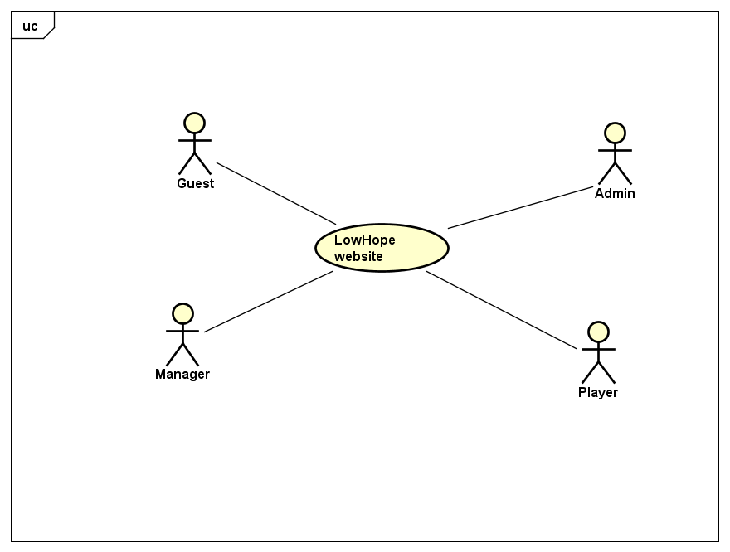

*Figure 6: User case level 0*

### **3.2.2. User Requirement.**

#### **3.2.2.1 Guest**

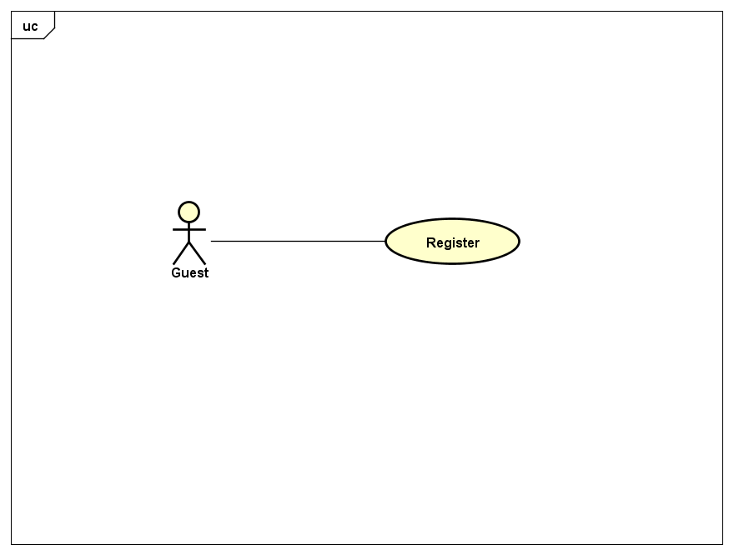

*Figure 7: User case level 1 – Guest.*

#### **3.2.2.2 Player**

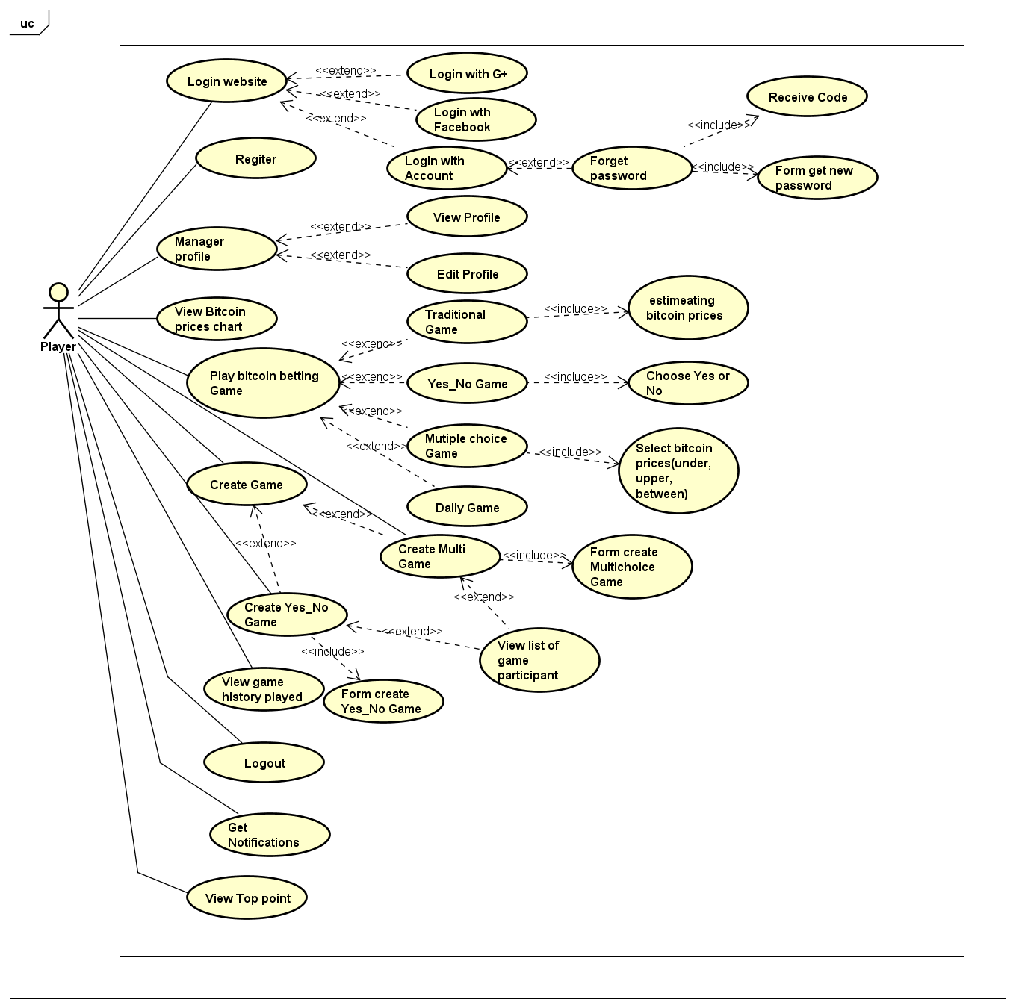

*Figure 8: User case level 1– Player.*

#### **3.2.2.3 Admin**

#### **3.2.2.4 Manager**

## **3.3. System Requirement Specification.**

### **3.3.1. External Interface Requirement.**

#### **3.3.1.1 User Interface**

* Vietnamese is the official language of LowHope website.
* The main screen is familiar with the user.
* Each user interface element must be arranged logically, not overlapped over other, allowing user access easily.
* If any error occurs, the system displays a friendly error message.
* The interface is friendly with the user.

#### **3.3.1.2 Hardware Interfaces**

* All web browsers: Google chrome, Firefox, IE…

#### **3.3.1.3 Software Interfaces**

* LowHope run on Sublime Text 3 and My SQL.

#### **3.3.1.4 Constraints (Communications Protocol)**

* The scope of the project is not changed in the process of the project so time and funding of the project is unchanged.
* Must finish of the project work within 90 days.
* Must work within the available resources.
* The customer is not acceptable if the product delay of delivery 10 days, the product does quality, not conforming to the requirements will not be accepted.
* Risks relating to the project must be notified in advance.

### **3.3.2. System Use Case**

Below are the detail use cases for every user groups:



*Figure 9: User case level 1-Guest.*



*Figure 10: User case level 1-Player*

### **3.3.3. List of Use Case**

|  |  |  |  |
| --- | --- | --- | --- |
| **No** | **Use case ID** | **Name** | **Primary Actor** |
|  | UC1.01 | Register | Guest |
|  | UC2.01 | Login | Player, Manager, Admin |
|  | UC2.02 | Forget password | Player |
|  | UC2.03 | Logout | Player, Manager, Admin |
|  | UC2.04 | View profile | Player, Manager, Admin |
|  | UC2.05 | Edit profile | Player, Manager, Admin |
|  | UC2.06 | View chart of bitcoin price | Player |
|  | UC2.07 | Play Traditional betting Game | Player |
|  | UC2.08 | Play Yes_No betting Game | Player |
|  | UC2.09 | Play Multichoice betting game | Player |
|  | UC2.10 | Create Yes_No betting game | Player |
|  | UC2.11 | Create Multichoice betting game | Player |
|  | UC2.12 | View list of participant in a game | Player |
|  | UC2.13 | View history of player | Player |
|  | UC2.14 | View notifications | Player |
|  | UC2.15 | View top point | Player |
|  |  |  |  |
|  |  |  |  |
|  |  |  |  |
|  |  |  |  |
|  |  |  |  |
|  |  |  |  |
|  |  |  |  |
|  |  |  |  |

### **3.3.4. Business Rules**

|  |  |
| --- | --- |
| **No** | **Description** |
| **B01** | All of register textbox must not be empty. |
| **B02** | Strong passwords with min 8 - max 15 character length, at least one uppercase letter, one lowercase letter, one number, one special character (all, not just defined), space is not allowed. |
| **B03** | Phone number use for account must contains 10 or 11 numbers. And it must begin with “09” if contains 10 numbers and “01” if contains 11 numbers. |
| **B04** | Email use for account must be standard email form and exist. |
| **B05** | Google use for account must be standard Google form and exist. |
| **B06** | Bet amount must be greater than 0 |
| **B07** | Action must wait permission of admin or manager |
| **B08** | Ban account cannot login system. |

### **3.3.5. Use Case Specification**

*UC1 – 01 Register*

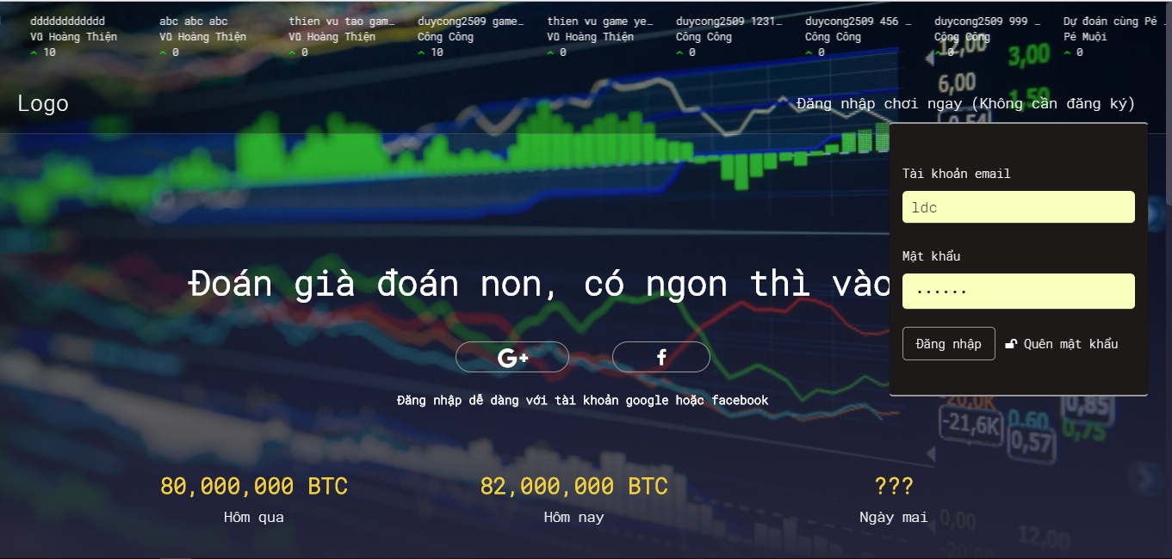

*Figure 11: Screen of UC1-01 Register*

|  |  |  |  |  |
| --- | --- | --- | --- | --- |
| **USE CASE-1 SPECIFICATION** : Register | | | | |
| **Use-case No.** | <UC1.01> | **Use-case Version** | | <1.0> |
| **Use-case Name** | Register | | | |
| **Author** | TungNT | | | |
| **Date** | 02/10/2017 | **Priority** | High | |
| **User:** Guest  **Summary:** The user uses this feature to register player account.  **Description:** Guest register an account to become player and login system to use.  **Goal:** Register account successfully.  **Triggers:** The user clicks on link “Đăng Nhập” in the login page.  **Preconditions:** Users must register with accurate personal information.  **Post Conditions:** The user has an account to login system.  **Main Success Scenario:**   |  |  | | --- | --- | | User | System | | 1. User clicks on link “Đăng Nhập” in the login page. |  | |  | 2. Login to LowHope website | | 3. User fill information in corresponding textbox and click on button “Đăng nhập”. |  | |  | 4. Check input information and Login to LowHope website |   **Alternative Scenario:** N/A  **Exceptions:**   |  |  | | --- | --- | | User | System | | 3. User does not fill standard email form. |  | |  | 4. Display error message “Tài khoản email không đúng” | | 3. User use invalid password to register |  | |  | 4. Display error message “Độ dài mật khẩu tối thiểu từ 8 ký tự- tối đa 15 ký tự, ít nhất một chữ cái viết hoa, một chữ thường, một chữ số, một ký tự đặc biệt” |   **Relationships:** N/A  **Business Rules:** B01, B02, B03, B04, B05 | | | | |

*UC2 – 01 Login*

|  |  |  |  |  |
| --- | --- | --- | --- | --- |
| **USE CASE-2 SPECIFICATION** : Login | | | | |
| **Use-case No.** | <UC2.01> | **Use-case Version** | | <1.0> |
| **Use-case Name** | Login | | | |
| **Author** | TungNT | | | |
| **Date** | 02/10/2017 | **Priority** | High | |
| **User:** Admin, Manager, Player.  **Summary:** The user uses this feature to login account.  **Description:** User fill email and password or user can use facebook account; google+ account to login into LowHope website.  **Goal:** Login account successfully.  **Triggers:** The user clicks on “Đăng nhập” in the login page. User can clicks on facebook or google+ account in the login page.  **Preconditions:** Users must have account in system or user have a facebook or google+ account.  **Post Conditions:** Display page matching each role account.  **Main Success Scenario:**   |  |  | | --- | --- | | User | System | | 1. User clicks on button “facebook” or “G+” in the page |  | |  | 2. Display a page to choose facebook account or google+ account. | | 3. User choose facebook account or google+ account and click on account |  | |  | 4. Accept the user to login system. | | 5 User fill email and password in login form and clicks on button “Đăng nhập” in this form. |  | |  | 6. Accept the user to login system. |   **Alternative Scenario:** N/A  **Exceptions:**   |  |  | | --- | --- | | User | System | | 5. User use invalid username or invalid password to login. |  | |  | 6. Display error message “tài khoản email không đúng; sai password vui lòng thử lại sau”. | | 5. User does not fill the username to login |  | |  | 6. Display error message “Bạn chưa điền tên tài khoản” | | 5. User does not fill the password to login |  | |  | 6. Display error message “Bạn chưa điền mật khẩu” |   **Relationships:** N/A  **Business Rules:** B01, B02, B03, B04, B05, B07 | | | | |

*UC2 – 02 Forget password*



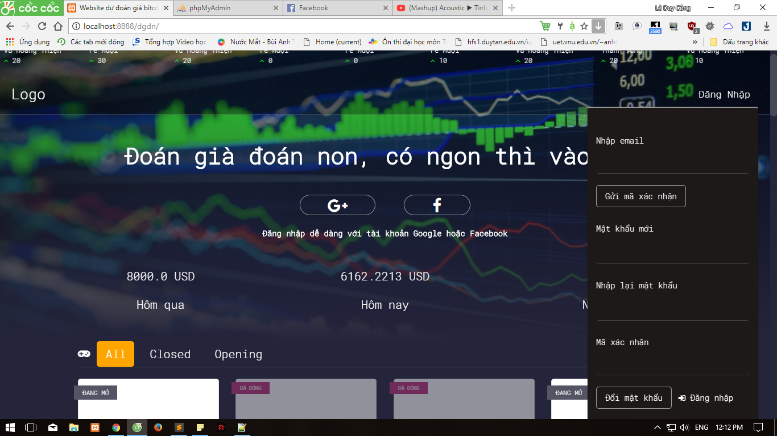

*Figure 12: Screen of UC2-02 Forget Password*

|  |  |  |  |  |
| --- | --- | --- | --- | --- |
| **USE CASE-3 SPECIFICATION** : Forget password | | | | |
| **Use-case No.** | <UC2.02> | **Use-case Version** | | <1.0> |
| **Use-case Name** | Forget password | | | |
| **Author** | TungNT | | | |
| **Date** | 02/10/2017 | **Priority** | High | |
| **User:** Player  **Summary:** The user uses this feature to get new password  **Goal:** Login account successfully.  **Description:** If user forget password, user can get new password.  **Triggers:** The user clicks on “Quên mật khẩu” in the login page.  **Preconditions:** Users must have account in system.  **Post Conditions:** Display forget password screen.  **Main Success Scenario:**   |  |  | | --- | --- | | User | System | | 1. User clicks on button “Quên mật khẩu” |  | |  | 2. Display forget password screen. | | 3. User fill valid email and clicks on button “Gửi mã xác nhận” in this form to give verification code. |  | |  | 4. Display successful sending verification code to user’s email | | 5 User fill new password; confirm new password and verification code then user clicks on button “Đổi mật khẩu” |  | |  | 6. Check information and display successful. |   **Alternative Scenario:** N/A  **Exceptions:**   |  |  | | --- | --- | | User | System | | 3. User use invalid email to get verification code. |  | |  | 4. Display error message “Email không hợp lệ”. | | 5. User fill invalid password |  | |  | 6. Display error message “Độ dài mật khẩu tối thiểu từ 8 ký tự- tối đa 15 ký tự, ít nhất một chữ cái viết hoa, một chữ thường, một chữ số, một ký tự đặc biệt”. | | 5. User fill confirm password incorrect. |  | |  | 6. Display error message “Mật khẩu mới và mật khẩu xác nhận không chính xác” | | 5.User fill verification code incorrect |  | |  | 6. Display error message “Mã xác nhận không hợp lệ” |   **Relationships:** N/A  **Business Rules:** | | | | |

*UC2 – 03 Logout*

|  |  |  |  |  |
| --- | --- | --- | --- | --- |
| **USE CASE-4 SPECIFICATION** : Logout | | | | |
| **Use-case No.** | <UC2.03> | **Use-case Version** | | <1.0> |
| **Use-case Name** | Logout | | | |
| **Author** | Tungnt | | | |
| **Date** | 02/10/2017 | **Priority** | High | |
| **User:** Admin, Manager, Player.  **Summary:** The user uses this feature to logout account.  **Goal:** Logout account successfully.  **Description:** User logout website LowHope.  **Triggers:** The user clicks on button “Đăng xuất” in the page.  **Preconditions:** Users must login in system.  **Post Conditions:** Display login page.  **Main Success Scenario:**   |  |  | | --- | --- | | User | System | | 1. User clicks on button “Đăng xuất” in the page. |  | |  | 2. Display login page. |   **Alternative Scenario:** N/A  **Exceptions:** N/A  **Relationships:** N/A  **Business Rules:** N/A | | | | |

*UC2 – 04 View Profile*

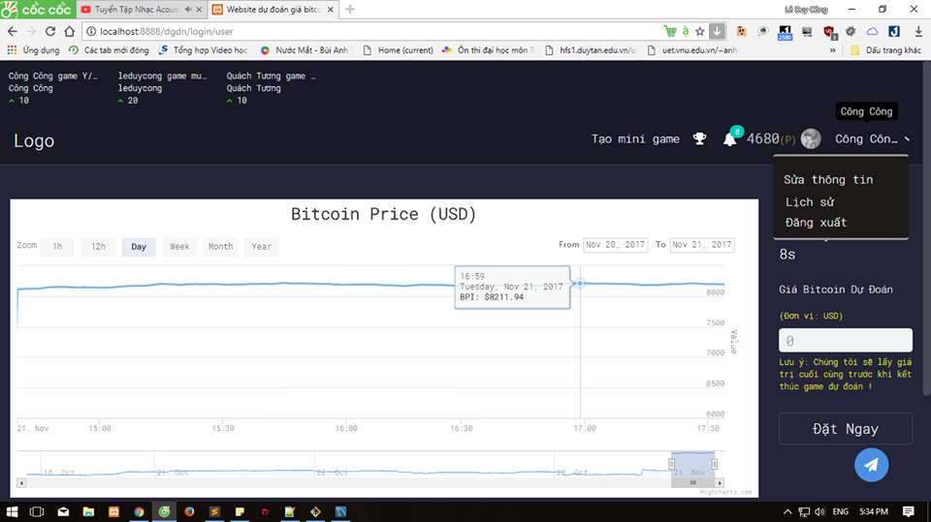

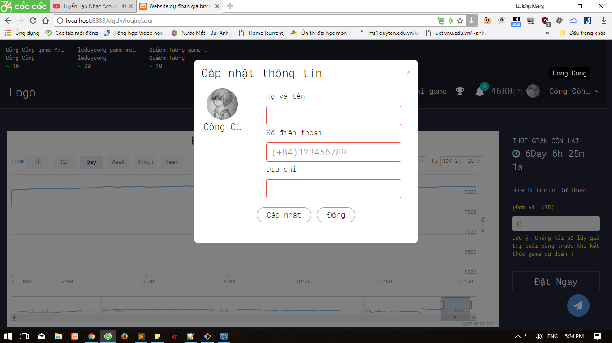

*Figure 13: Screen of UC2-04 View Profile*

|  |  |  |  |  |
| --- | --- | --- | --- | --- |
| **USE CASE-5 SPECIFICATION** : View Profile | | | | |
| **Use-case No.** | <UC2.04> | **Use-case Version** | | <1.0> |
| **Use-case Name** | View Profile | | | |
| **Author** | TungNT | | | |
| **Date** | 02/10/2017 | **Priority** | High | |
| **User:** Player, Admin, Manager.  **Summary:** The user uses this feature to view personal information.  **Goal:** View personal information.  **Description:** User view personal information.  **Triggers:** The user clicks on account name and select “Sửa thông tin” in the page.  **Preconditions:** Users must login in system.  **Post Conditions:** Display personal information screen.  **Main Success Scenario:**   |  |  | | --- | --- | | User | System | | 1. User clicks on account name option in the page and choose “Sửa thông tin” in the page. |  | |  | 2. Display personal information page. |   **Alternative Scenario:** N/A  **Exceptions:** N/A  **Relationships:** N/A  **Business Rules:** N/A | | | | |

*UC2 – 05 Edit Profile*

|  |  |  |  |  |
| --- | --- | --- | --- | --- |
| **USE CASE-6 SPECIFICATION** : Edit Profile | | | | |
| **Use-case No.** | <UC2.05> | **Use-case Version** | | <1.0> |
| **Use-case Name** | Edit profile | | | |
| **Author** | TungNT | | | |
| **Date** | 02/10/2017 | **Priority** | Low | |
| **User:** Player, Admin, Manager.  **Summary:** The user uses this feature to edit personal information.  **Goal:** Change personal information.  **Description:** User modify personal information.  **Triggers:** User clicks on account name option in the page and choose “Sửa thông tin” in the page.  **Preconditions:** Users must login in system.  **Post Conditions:** Display Edit personal information page.  **Main Success Scenario:**   |  |  | | --- | --- | | User | System | | 1. User clicks on account name option and choose “Sửa thông tin” in the page. |  | |  | 2. Display change personal information page. | | 3. User fill information want to change in corresponding textbox and click button “Cập nhật” |  | |  | 4. Check information and display notification. |   **Alternative Scenario:** N/A  **Exceptions:**   |  |  | | --- | --- | | User | System | | 3. User fill incorrect information. |  | |  | 4. Display incorrect information notification. |   **Relationships:** N/A  **Business Rules:** B01, B02, B04, B05, B06 | | | | |

*UC2 – 06 View Bitcoin price Chart*

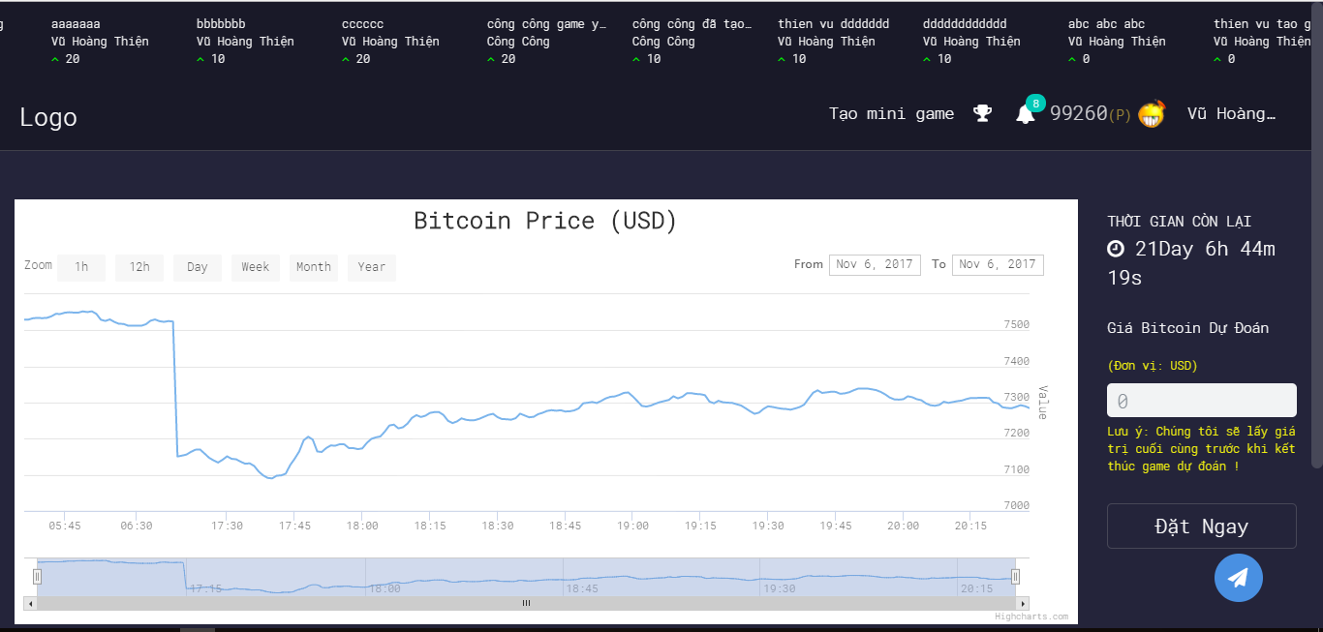

*Figure 14: Screen of UC2-06 View Bitcoin price chart*

|  |  |  |  |  |
| --- | --- | --- | --- | --- |
| **USE CASE-7 SPECIFICATION** : View Bitcoin Price Chart | | | | |
| **Use-case No.** | <UC2.06> | **Use-case Version** | | <1.0> |
| **Use-case Name** | View Bitcoin Price Chart | | | |
| **Author** | TungNT | | | |
| **Date** | 03/10/2017 | **Priority** | High | |
| **User:** Player  **Summary:** The user uses this feature to view bitcoin price chart.  **Goal:** View bitcoin price chart.  **Description:** Player view chart of bitcoin price.  **Triggers:** The user click on “Đăng nhập” or “Facebook”, “G+” to login into Home page then player will see the chart of bitcoin price.  **Preconditions:** Users must login in system.  **Post Conditions:** Display chart of bitcoin price.  **Main Success Scenario:**   |  |  | | --- | --- | | User | System | | 1. User click on “Đăng nhập” or “Facebook” , “G+” in the login page to go to Homepage |  | |  | 2. Display Home page and it will show chart of bitcoin price. |   **Alternative Scenario:** N/A  **Exceptions:** N/A  **Relationships:** N/A  **Business Rules:** B08 | | | | |

*UC2 – 07 Play Traditional Game*

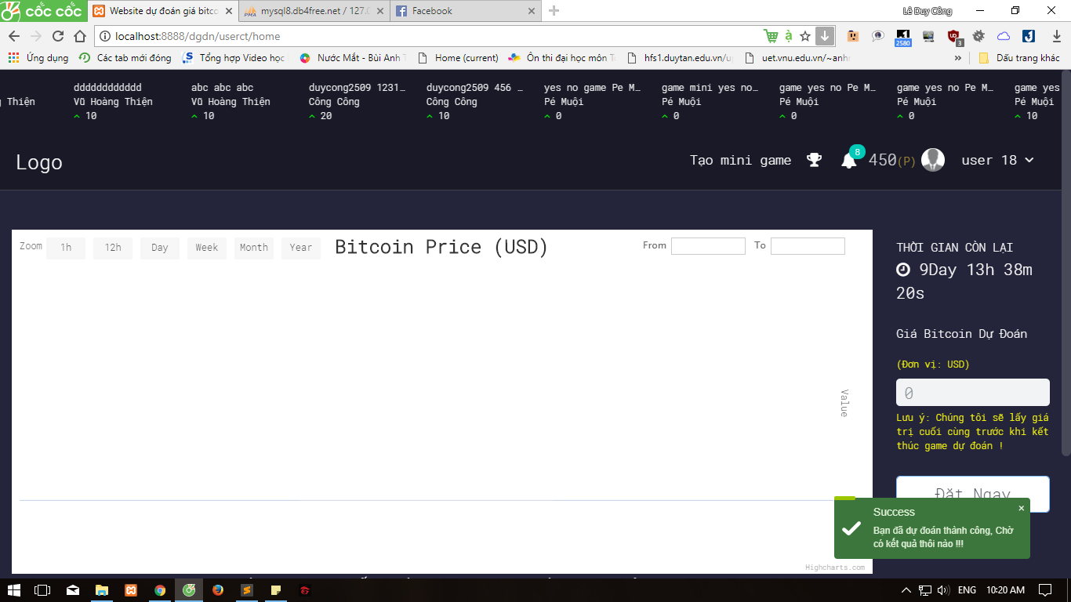

*Figure 15: Screen of UC2-07 Play Traditional Game*

|  |  |  |  |  |
| --- | --- | --- | --- | --- |
| **USE CASE-8 SPECIFICATION** : Play Traditional Game | | | | |
| **Use-case No.** | <UC2.07> | **Use-case Version** | | <1.0> |
| **Use-case Name** | Play Traditional Game | | | |
| **Author** | TungNT | | | |
| **Date** | 03/10/2017 | **Priority** | High | |
| **User:** Player  **Summary:** The player uses this feature to play traditional betting game.  **Goal:** Traditional betting game is played.  **Description:** Player play traditional betting game. The betting cost of a traditional betting game is 100 point.  **Triggers:** The user click on “Đăng nhập” or “Facebook”, “G+” to login into Home page then player will see the chart of bitcoin price and traditional betting game. Player are played traditional betting game when time of game is not over.  **Preconditions:** Player must login in system and time of game is not over. Player must have more than 100 point.  **Post Conditions:** Display Traditional betting game screen.  **Main Success Scenario:**   |  |  | | --- | --- | | User | System | | 1. Player click on “Đăng nhập” or “Facebook” , “G+” in the login page to go to Homepage |  | |  | 2. Display Home page and screen will show traditional betting game and chart of bitcoin price. | | 3. When time of game is not over. Player fill estimating bitcoin price then player wait time of game over. Player compare estimating bitcoin price with bitcoin price at time of game is over.  Player click button “. Player click button “ Đặt Ngay” to bet. |  | |  | 4. System confirm player’s estimating bitcoin price and display successfully notification “Bạn đã dự đoán thành công. Chờ có kết quả thôi nào”. |   **Alternative Scenario:** N/A  **Exceptions:**   |  |  | | --- | --- | | User | System | | 3. Player input estimating bitcoin price is less than 0 or character other number. |  | |  | 4. Display error message “Vui lòng nhập đúng định dạng trường dự đoán”. | | 3. Player estimated bitcoin price when time of game is over |  | |  |  |   **Relationships:** N/A  **Business Rules:** B08 | | | | |

*UC2 – 08 Play Yes_No Game*

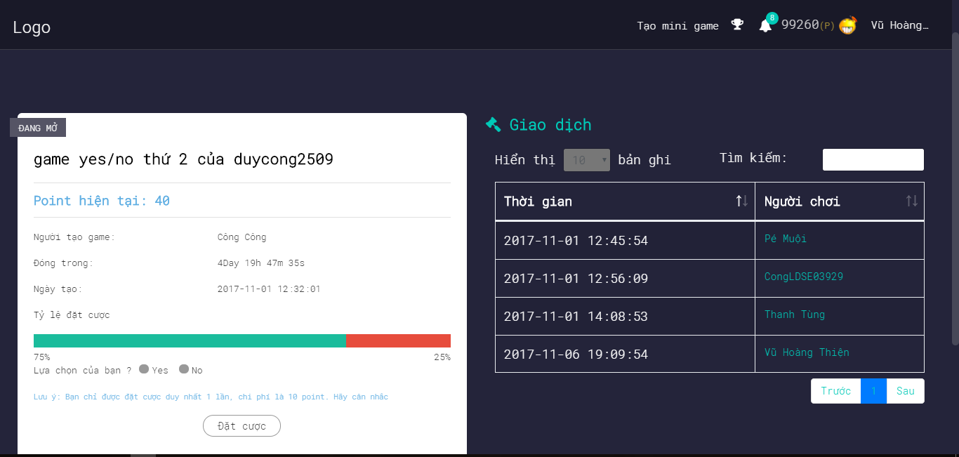

*Figure 16: Screen of UC2-08 Play Yes_No betting Game*

|  |  |  |  |  |
| --- | --- | --- | --- | --- |
| **USE CASE-9 SPECIFICATION** : Play Yes_No betting Game | | | | |
| **Use-case No.** | <UC2.08> | **Use-case Version** | | <1.0> |
| **Use-case Name** | Play Yes_No betting Game | | | |
| **Author** | TungNT | | | |
| **Date** | 03/10/2017 | **Priority** | High | |
| **User:** Player  **Summary:** The player uses this feature to play Yes_No betting game.  **Goal:** Yes_No betting game is played.  **Description:** Player play Yes_No betting game. Yes_No betting game was created by a player. Players aren’t allowed to play games created by themselves. The betting cost of a Yes_No betting game is 10 point. If player win a game, player will be received 20 point. A game only allow 40 players to play game.  **Triggers:** The user click on item infinite Slideshow “Yes_No game”. Player are played Yes_No betting game when time of this game is not over.  **Preconditions:** Player must login in system and time of this game is not over.  **Post Conditions:** Display Yes_No betting game screen.  **Main Success Scenario:**   |  |  | | --- | --- | | User | System | | 1. Player choose a Yes_No betting game on item infinite Slideshow then player click on item infinite Slideshow “Yes_No game” to go to Yes_No betting game screen |  | |  | 2. Display Yes_No betting game page | | 3. Player read question of game is chose by this player then player select “Yes” or “No” based on question of this game. The betting cost of a Yes_No betting game is 10 point. If player win a game, player will be received 20 point. Player click button “ Đặt Cược” to bet.  A game only allow 40 players to play game. |  | |  | 4. System confirm player’s choice and display successfully notification “Bạn đã dự đoán thành công. Chờ có kết quả thôi nào”. |   **Alternative Scenario:** N/A  **Exceptions:**   |  |  | | --- | --- | | User | System | | 3. Player bets twice for a Yes_No betting game. |  | |  | 4. Display error message “Bạn đã đặt cược game này! Vui long chọn game khác để chơi”. | | 3. Players play Yes_No betting game is created by themselves. |  | |  | 4. Display error message “Bạn không được chơi game do mình tạo ra”. | | 3. Player play a game but this game has been enough players (40 players/a game). |  | |  | 4. Display message ”Rất tiếc game này đã đủ người chơi. Vui long chọn game khác để chơi” |   **Relationships:** N/A  **Business Rules:** B08 | | | | |

*UC2 – 09 Play MultiChoice Game*

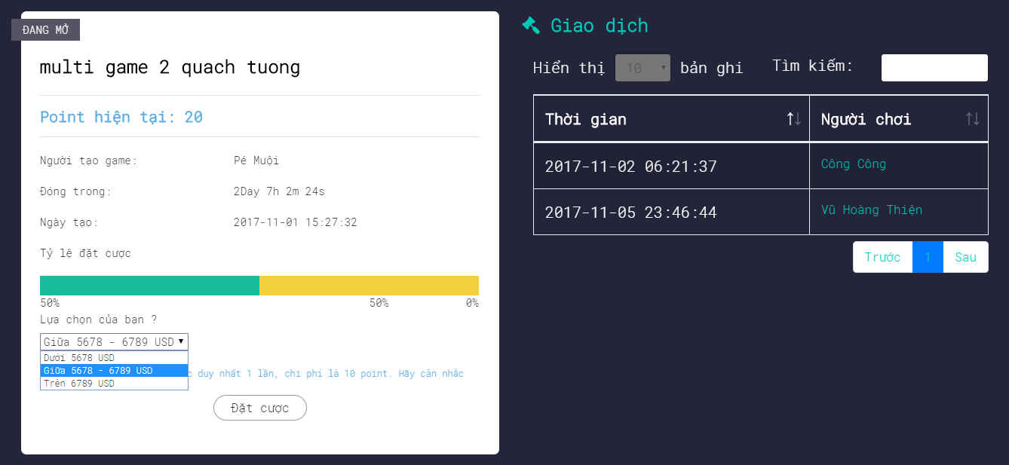

*Figure 17: Screen of UC2-09 Play MultiChoice betting Game*

|  |  |  |  |  |
| --- | --- | --- | --- | --- |
| **USE CASE-10 SPECIFICATION** : Play MultiChoice betting Game | | | | |
| **Use-case No.** | <UC2.09> | **Use-case Version** | | <1.0> |
| **Use-case Name** | Play MultiChoice betting Game | | | |
| **Author** | TungNT | | | |
| **Date** | 03/10/2017 | **Priority** | High | |
| **User:** Player  **Summary:** The player uses this feature to play Multichoice betting game.  **Goal:** Multichoice betting game is played.  **Description:** Player play Multichoice betting game. Multichoice betting game was created by a player. Players aren’t allowed to play games created by themselves. The betting cost of a Multichoice betting game is 10 point. If player win a game, player will be received 20 point. A game only allow 40 players to play game.  **Triggers:** The user click on item infinite Slideshow “Multichoice game”. Player are played Multichoice betting game when time of this game is not over.  **Preconditions:** Player must login in system and time of this game is not over.  **Post Conditions:** Display Multichoice betting game screen.  **Main Success Scenario:**   |  |  | | --- | --- | | User | System | | 1. Player choose a Multichoice betting game on item infinite Slideshow then player click on item infinite Slideshow “Multichoice game” to go to Multichoice betting game screen |  | |  | 2. Display Multichoice betting game page | | 3. Player read question of game is chose by this player then player select “under” or “upper” or “between” based on question of this game. The betting cost of a Multichoice betting game is 10 point. If player win a game, player will be received 20 point. Player click button “ Đặt Cược” to bet.  A game only allow 40 players to play game. |  | |  | 4. System confirm player’s choice and display successfully notification “Bạn đã dự đoán thành công. Chờ có kết quả thôi nào”. |   **Alternative Scenario:** N/A  **Exceptions:**   |  |  | | --- | --- | | User | System | | 3. Player bets twice for a Multichoice betting game. |  | |  | 4. Display error message “Bạn đã đặt cược game này! Vui long chọn game khác để chơi”. | | 3. Players play Multichoice betting game is created by themselves. |  | |  | 4. Display error message “Bạn không được chơi game do mình tạo ra”. | | 3. Player play a game but this game has been enough players (40 players/a game). |  | |  | 4. Display message ”Rất tiếc game này đã đủ người chơi. Vui long chọn game khác để chơi”. |   **Relationships:** N/A  **Business Rules:** B08 | | | | |

*UC2 – 10 Create Yes_No betting Game*



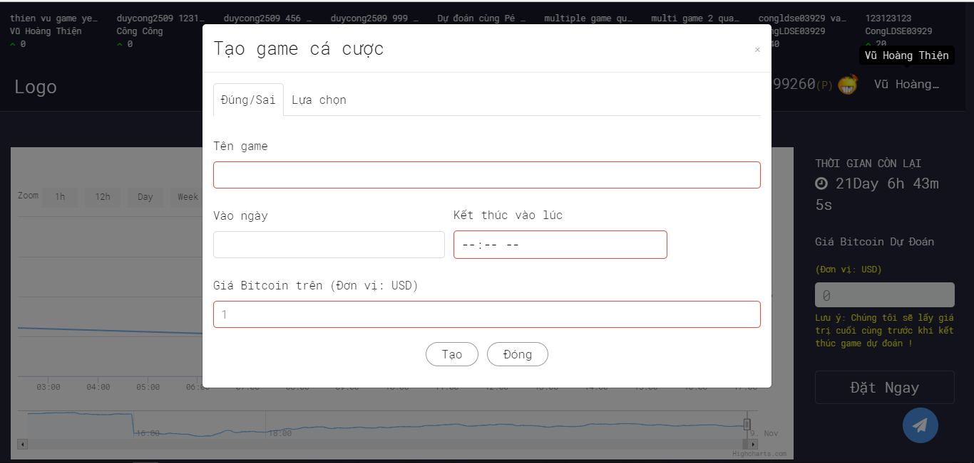

*Figure 18: Screen of UC2-10 Create Yes_No betting Game*

|  |  |  |  |  |
| --- | --- | --- | --- | --- |
| **USE CASE-11 SPECIFICATION** : Create Yes_No betting Game | | | | |
| **Use-case No.** | <UC2.10> | **Use-case Version** | | <1.0> |
| **Use-case Name** | Create Yes_No betting Game | | | |
| **Author** | TungNT | | | |
| **Date** | 03/10/2017 | **Priority** | High | |
| **User:** Player  **Summary:** The player uses this feature to Create Yes_No betting game for everyone to play.  **Goal:** Create Yes_No betting game is created.  **Description:** Player create Yes_No betting game for everyone to play. Players who want to create a Yes_No betting game need to pay 50 point. If player win a game, creator of game will be lost 20 point to a winner  **Triggers:** The player click on link “Tạo Mini game” in the home page to go to game creating form then player click link “Đúng/Sai” into Yes_No betting game creating form.  **Preconditions:** Player must login in system and Player must be at least 50 point to create Yes_No betting game.  **Post Conditions:** Display Yes_No betting game creation form.  **Main Success Scenario:**   |  |  | | --- | --- | | User | System | | 1. Player click link “Tạo mini name” in the homepage to go to game creating form then Player click link “Đúng/Sai” to go to Yes_No betting game creating form. |  | |  | 2. Display Yes_No betting game creating form. | | 3. When time of game is not over. Player fill name of game “Tên game”, start date of game “Vào ngày” and end time “Kết thúc vào lúc” then player fill estimating bitcoin price is increase “Giá bitcoin trên (Đơn vị: USD)”.  Player click button “Taọ” to create game.  If player win a game, creator of game will be lost 20 point to a winner |  | |  | 4. System confirm player’s game creating and display successfully notification “Chúc mừng bạn đã tạo game thành công”. | | 5. Player click “Đóng” to close form. |  | |  | 6. System display into Homepage. |   **Alternative Scenario:** N/A  **Exceptions:**   |  |  | | --- | --- | | User | System | | 3. Player fill invalid name of game. |  | |  | 4. Display error message “Tên game phải chứa từ 6 đến 35 ký tự”. | | 3. Player input “Giá bitcoin trên (Đơn vị : USD) is less than 0 or character other number. |  | |  | 4. Display error message “Giá Bitcoin không đúng định dạng ”. |   **Relationships:** N/A  **Business Rules:** B08 | | | | |

*UC2 – 11 Create Multichoice betting Game*



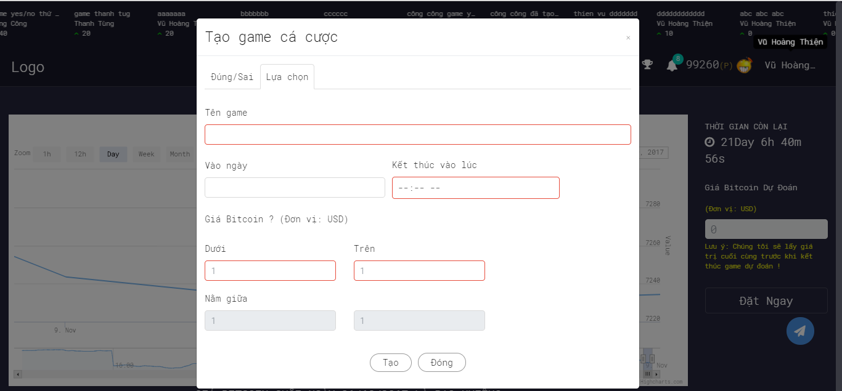

*Figure 19: Screen of UC2-11 Create Multichoice betting Game*

|  |  |  |  |  |
| --- | --- | --- | --- | --- |
| **USE CASE-12 SPECIFICATION** : Create Multichoice betting Game | | | | |
| **Use-case No.** | <UC2.11> | **Use-case Version** | | <1.0> |
| **Use-case Name** | Create Multichoice betting Game | | | |
| **Author** | TungNT | | | |
| **Date** | 03/10/2017 | **Priority** | High | |
| **User:** Player  **Summary:** The player uses this feature to Create Multichoice betting game for everyone to play.  **Goal:** Create Multichoice betting game is created.  **Description:** Player create Multichoice betting game for everyone to play. Players who want to create a Multichoice betting game need to pay 50 point. If player win a game, creator of game will be lost 20 point to a winner.  **Triggers:** The player click on link “Tạo Mini game” in the home page to go to game creating form then player click link “lựa chọn” into Multichoice betting game creating form.  **Preconditions:** Player must login in system and Player must be at least 50 point to create Multichoice betting game.  **Post Conditions:** Display Multichoice betting game creation form.  **Main Success Scenario:**   |  |  | | --- | --- | | User | System | | 1. Player click link “Tạo mini name” in the homepage to go to game creating form then Player click link “Lựa chọn” to go to Multichoice betting game creating form. |  | |  | 2. Display Multichoice betting game creating form. | | 3. When time of game is not over. Player fill name of game “Tên game”, start date of game “Vào ngày” and end time “Kết thúc vào lúc” then player fill estimating bitcoin price is increase “Giá bitcoin trên (Đơn vị: USD)”.  Player click button “Taọ” to create game. |  | |  | 4. System confirm player’s game creating and display successfully notification “Chúc mừng bạn đã tạo game thành công”. | | 5. Player click “Đóng” to close form. |  | |  | 6. System display into Homepage. |   **Alternative Scenario:** N/A  **Exceptions:**   |  |  | | --- | --- | | User | System | | 3. Player fill invalid name of game. |  | |  | 4. Display error message “Tên game phải chứa từ 6 đến 35 ký tự”. | | 3. Player input “Giá bitcoin trên (Đơn vị : USD) is less than 0 or character other number. |  | |  | 4. Display error message “Giá Bitcoin không đúng định dạng”. |   **Relationships:** N/A  **Business Rules:** B08 | | | | |

*UC2 – 12 View list of participant in a game.*



*Figure 20: Screen of UC2-12 Vỉew list of game participant.*

|  |  |  |  |  |
| --- | --- | --- | --- | --- |
| **USE CASE-13 SPECIFICATION**: View History of participants in a game. | | | | |
| **Use-case No.** | <UC2.11> | **Use-case Version** | | <1.0> |
| **Use-case Name** | View History of participants in a game. | | | |
| **Author** | TungNT | | | |
| **Date** | 03/10/2017 | **Priority** | High | |
| **User:** Player  **Summary:** The player uses this feature to view list of participants in a game.  **Goal:** Player view who has participated in this game.  **Description:** Player view who have participated betting in a game (Multichoice betting game or Yes_No betting game).  **Triggers:** Player must choose a betting bitcoin game (Multichoice betting game or Yes_No betting game) to view who has participated in this game. The player click on item infinite Slideshow a game. Player are viewed who have participated betting in a game when time of this game is not over.  **Preconditions:** Player must login in system and time of this game is not over.  **Post Conditions:** Display list of players who have participated betting in a game screen.  **Main Success Scenario:**   |  |  | | --- | --- | | User | System | | 1. Player choose a betting game on item infinite Slideshow then player click on item infinite Slideshow “name of game to go to list of players have participated betting in a game screen. |  | |  | 2. Display list of players have participated betting in a game screen. | | 3. When time of game is not over. Player view right side of screen is a table consisting of two columns that are time column and participant column. This table include list of players who participated in this game. |  | |  | 4. System display list of players have participated betting in this game. | | 5. Player can search players who participated in this game by name or time. |  | |  | 6. System display into Homepage. |   **Alternative Scenario:** N/A  **Exceptions:** N/A  **Relationships:** N/A  **Business Rules:** B08 | | | | |

*UC2 – 13 View history of player*

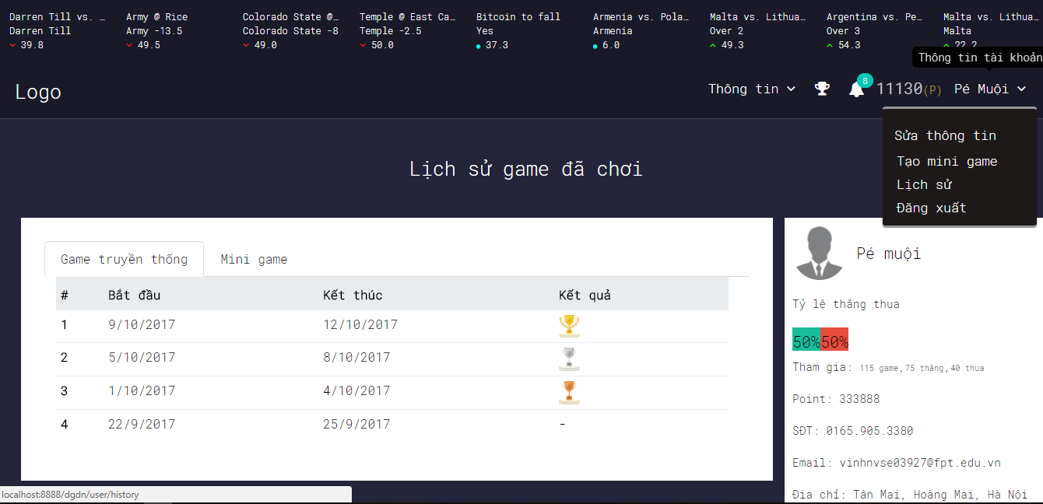

*Figure 21: Screen of UC2-13 View history of player*

|  |  |  |  |  |
| --- | --- | --- | --- | --- |
| **USE CASE-14 SPECIFICATION** : View History of player | | | | |
| **Use-case No.** | <UC2.13> | **Use-case Version** | | <1.0> |
| **Use-case Name** | View history of player | | | |
| **Author** | TungNT | | | |
| **Date** | 04/10/2017 | **Priority** | High | |
| **User:** Player.  **Summary:** The use uses this feature to view history of games are played by player.  **Goal:** View history of games are played by player.  **Description:** Player View history of games are played by player.  **Triggers:** User clicks on account name option in the homepage and choose “Lịch sử” in the homepage then Player clicks link “Game truyền thống” to view to view history of traditional bitcoin betting games are played and player clicks “Mini game” to view history of mini games are played by player.  **Preconditions:** Users must login in system.  **Post Conditions:** Display history of games are played of player page.  **Main Success Scenario:**   |  |  | | --- | --- | | User | System | | 1. Player clicks on account name option and choose “Lịch Sử” in the Homepage. |  | |  | 2. Display history of games are played of player Page. | | 3. Player clicks link “Game truyền thống” to view to view history of traditional bitcoin betting games are played |  | |  | 4. Display history table of traditional bitcoin betting games are played. Table consisting of start time, end time and award. | | 5. Player clicks link “Mini game” to view to view history of Mini games are played |  | |  | 6. Display history table of traditional bitcoin betting games are played. Table consisting of start time, end time and award. |   **Alternative Scenario:** N/A  **Exceptions:** N/A  **Relationships:** N/A  **Business Rules:** B01, B02, B04, B05, B06 | | | | |

*UC2 – 14 View Notifications*

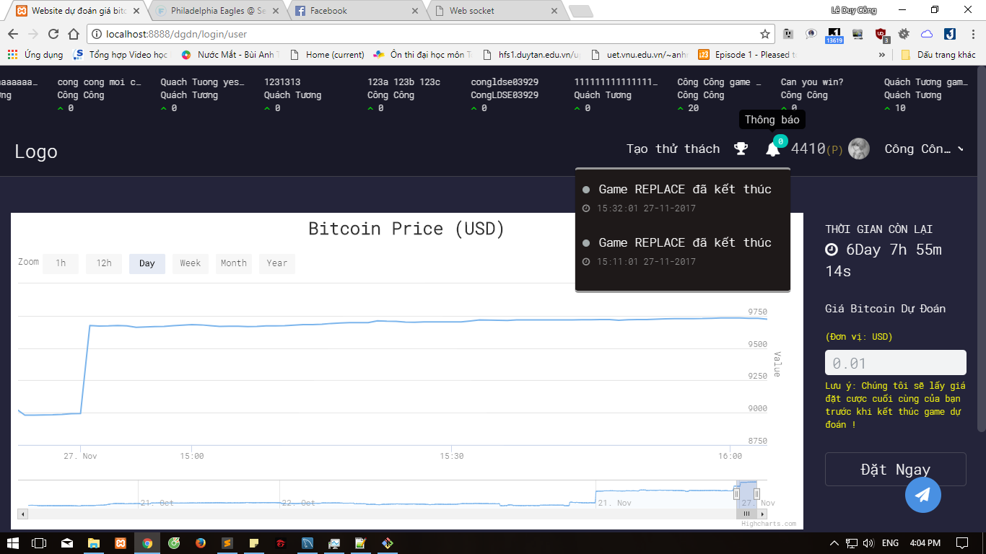

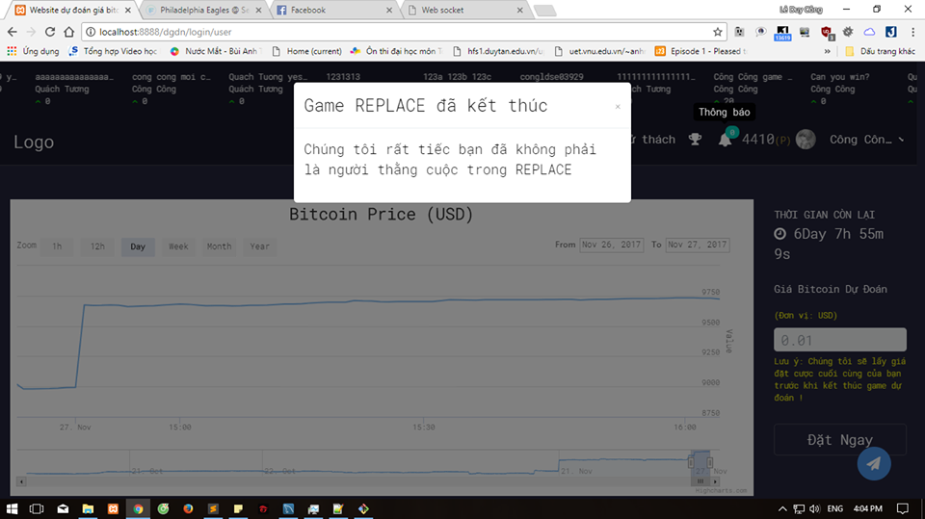

*Figure 22: Screen of UC2-14 View notification*

|  |  |  |  |  |
| --- | --- | --- | --- | --- |
| **USE CASE-15 SPECIFICATION** : View Notification | | | | |
| **Use-case No.** | <UC2.14> | **Use-case Version** | | <1.0> |
| **Use-case Name** | View Notification | | | |
| **Author** | TungNT | | | |
| **Date** | 04/10/2017 | **Priority** | Low | |
| **User:** Player.  **Summary:** The use uses this feature to view notification of manager sent a player.  **Goal:** View notification of manager.  **Description:** Player View notification of manager sent a player.  **Triggers:** Player clicks icon “Thông báo” in homepage then player chooses a notification to view.  **Preconditions:** Player must login in system and manager has sent a notification for player.  **Post Conditions:** Display list of notification of a player.  **Main Success Scenario:**   |  |  | | --- | --- | | User | System | | 1. Player clicks on icon “thông báo” in the homepage |  | |  | 2. Display list of notification of a player Popup. | | 3. Player choose a notification then player click on it to view. |  | |  | 4. Display notification details Popup. | | 5. If player don’t have a notification. |  | |  | 6. Display message “Không có thông báo nào để xem”. |   **Alternative Scenario:** N/A  **Exceptions:** N/A  **Relationships:** N/A  **Business Rules:** | | | | |

*UC2 – 15 View Top point*



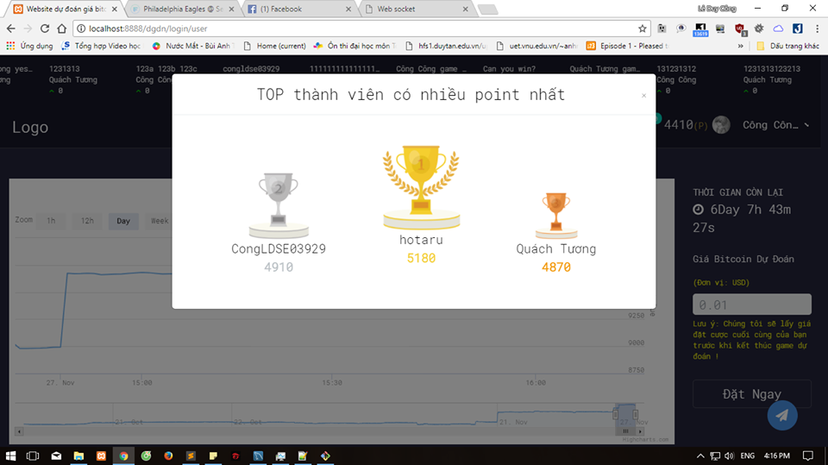

*Figure 23: Screen of UC2-15 View Top point*

|  |  |  |  |  |
| --- | --- | --- | --- | --- |
| **USE CASE-16 SPECIFICATION** : View Top point | | | | |
| **Use-case No.** | <UC2.15> | **Use-case Version** | | <1.0> |
| **Use-case Name** | View Top point | | | |
| **Author** | TungNT | | | |
| **Date** | 04/10/2017 | **Priority** | Low | |
| **User:** Player.  **Summary:** The use uses this feature to view top point  **Goal:** Player view top of players have the most point.  **Description:** Player view top of players have the most point with rank 1, 2 and 3.  **Triggers:** Player clicks icon “Top point” in the homepage  **Preconditions:** Player must login in system.  **Post Conditions:** Display list of player have the most point with rank 1, 2 and 3.  **Main Success Scenario:**   |  |  | | --- | --- | | User | System | | 1. Player clicks on icon “top point” in the homepage |  | |  | 2. Display list of player have the most point with rank 1, 2 and 3 Popup. |   **Alternative Scenario:** N/A  **Exceptions:** N/A  **Relationships:** N/A  **Business Rules:** | | | | |

### **3.3.6. Non-functional Requirements**

#### **3.3.6.1 Usability**

- User interface should be clear and easy to user

- User need no more than 10 minutes to learn how to use the application

- User need no more than 10 minutes to learn how to use manager page, admin page.

#### **3.3.6.2 Reliability**

* All inputs are validated.
* Data must be saved to database correctly.
* Data related to player information and bitcoin price information in LowHope website is controlled by Admin and Manager to avoid bad content and bad member in the system.

#### **3.3.6.3 Performance**

* Time for automatic processing: less than 10s.

#### **3.3.6.4 Interface**

##### **3.3.6.4.1 User Interface**

* User interface for application must be simple and clear.

##### **3.3.6.4.2 Hardware Interface**

- The LowHope website can run all web browsers: Google chrome, Firefox, IE…

##### **3.3.6.4.3 Security**

* Secure user accounts on Admin page and Manager page.

# CHAPTER 5: SOFTWARE TESTING DOCUMENT

## **5.1. Introduction.**

This document describes the plan for testing the developed software system against the software requirements as defined in the Software Requirements Specification and Detailed Document. The purpose of these tests is to make sure that the software system developed during the LowHope project complies with the requirements. The planning of these test will be done in the Planning phase, they will be designed in the Design phase and finally must be executed in the Coding phase and Testing phase of each cycle in the project.

## **5.2. Test Plan.**

### **5.2.1. Test Process**

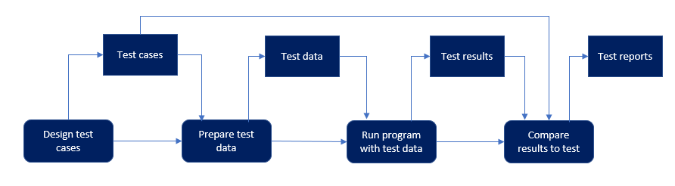

### **5.2.2. Requirement for Test**

#### **5.2.2.1. Test Items**

Developer will be performed unit test to ensure that all functions are working as expected. Tester will be under taking the responsibility of testing and validating the operation of the part that developed. The functions developed require completing design and execution of function to ensure proper coverage. The listing below identifies those items that have been identified as targets for testing. This list represents what will be tested.

##### **5.2.2.1.1 Functional Items**

The testing is done for all functionalities:

|  |  |  |  |
| --- | --- | --- | --- |
| **No** | **Use case ID** | **Name** | **Primary Actor** |
|  | UC1.01 | Register | Guest |
|  | UC2.01 | Login | Player, Manager, Admin |
|  | UC2.02 | Forget password | Player |
|  | UC2.03 | Logout | Player, Manager, Admin |
|  | UC2.04 | View profile | Player, Manager, Admin |
|  | UC2.05 | Edit profile | Player, Manager, Admin |
|  | UC2.06 | View chart of bitcoin price | Player |
|  | UC2.07 | Play Traditional betting Game | Player |
|  | UC2.08 | Play Yes_No betting Game | Player |
|  | UC2.09 | Play Multichoice betting game | Player |
|  | UC2.10 | Create Yes_No betting game | Player |
|  | UC2.11 | Create Multichoice betting game | Player |
|  | UC2.12 | View list of participant in a game | Player |
|  | UC2.13 | View history of player | Player |
|  | UC2.14 | View notifications | Player |
|  | UC2.15 | View top point | Player |
|  |  |  |  |
|  |  |  |  |
|  |  |  |  |
|  |  |  |  |
|  |  |  |  |
|  |  |  |  |
|  |  |  |  |
|  |  |  |  |

##### **5.2.2.1.2 Non Functional Items**

* User interface is clear and easy to understand. User need no more than 10 minutes to learn how to the application.

#### **5.2.2.2. Acceptance test criteria**

(Reference to FSoft norm 2013 for development project)

* The criteria for Test team to accept source code after Unit test of Development team:

- Number of UTC/KLOC: 80 - 90 Case/1KLOC

- Weight defects/KLOC: 8 - 9 bug/1KOLC

- Part coverage: 100%

* The criteria for accept the result of System test:

- Number of UTC/KLOC: 34 - 36 Case/1KLOC

- Weight defects/KLOC: 2 - 4 bug/1KOLC

- Part coverage: 100%

* The criteria accept the result of Acceptance test:

- Number of UTC/KLOC: 1 - 2 Case/1KLOC

- Weight defects/KLOC: 0 - 1 bug/1KOLC

- Part coverage: 100%

### **5.2.3. Test Approach**

* LowHope Website following V-Model process model:

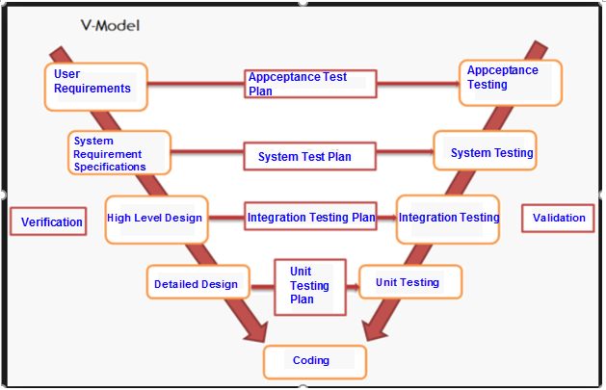

#### **5.2.3.1. Test stage**

|  |  |  |
| --- | --- | --- |
| **No** | **Test stages** | **Description** |
| 1 | **Unit Test** | * Unit Test is an important technique to improve software quality. * Unit testing is done by developers |
| 2 | **Integration Test** | * Integration Testing is a test that integrates a group of individual modules together with individual unit tests in each module. * A typical software project consists of several software modules, coded by different people. Integration testing focuses on testing the data transfer between modules and specific areas of use cases when all requirements are completed. * Integration test should be performed to ensure all components incorporate well. |
| 3 | **System Test** | * System test will be execute by LowHope tester * Testers will perform complete, end-to-end product testing staged in pre-production environment to validate that functions and system interfaces perform properly in production environment. After Integration test and Unit test. * Usually a software product is only tested on a demo environment, but the system test ensures that the system operates in a variety of environments and integrates with a variety of software and systems. * System test is a type of black box testing. System involves the operation of the outside of the software from the user's point of view. |
| 4 | **Acceptance Test** | * Acceptance testing is functional testing, which is done to check that the software meets the requirements of the customer. * Acceptable testing is performed by the customer, the user and the parties involved. * In acceptance testing will test the system to meet the business needs of the organization, the usability of the product. * Software runs with realistic data. * Acceptable testing is performed after system testing. |

### **5.2.4. Constraints**

- Working processing must be report Personal weekly report to PM and Supervisor.

- Deadline for testing only can be met if development progress is on time.

- At least one round of testing must be performed for requirements.

### **5.2.5. Rick List**

|  |  |  |  |  |  |
| --- | --- | --- | --- | --- | --- |
| **No** | **Description** | **Source** | **Probability** | **Exposure** | **Trigger** |
| 1 | Test phases is not completed due to testers’ lack of experience | Human | Medium |  |  |
|  |  |  |  |  |  |

### **5.2.6. Training Needs**

|  |  |  |
| --- | --- | --- |
| **No** | **Description** | **Description** |
| 1 | Testing process | - Learn & study by TungNT, CongLD, PhongLH, VinhNV.  - Understanding: Unit test, System test, Acceptance Test, Integration Test. Leaning from website: testing.vn |
| 2 | Test model | Learn & study by developer:  Understanding V-model |

### **5.2.7. Test Strategy**

#### **5.2.7.1. Test type**

##### **5.2.7.1.1. Function Testing**

Unit testing searches for defects in each function, and verifies the function of LowHope website. Website and tests whether its functions are implemented properly as required or not.

|  |  |
| --- | --- |
| **Test Objective** | Functional testing is a way of checking software to ensure that it has all the required functionality that's specified within its functional requirements. |
| **Technique** | Execute each use case, use-case flow, or function, using valid and invalid data, to verify the following:  - The expected results occur when valid data is used.  - The appropriate error or warning messages are displayed when invalid data is used. |
| **Completion criteria** | All planned tests have been executed. |
| **Special considerations** | Identify or describe those items or issues (internal or external) that impact the implementation and execution of function test |

##### **5.2.7.1.2. User Interface Testing**

Integration testing tests interfaces between components (website screen), interactions with different parts of a system, and interfaces between systems.

|  |  |
| --- | --- |
| **Test Objective** | Verify the following:  Navigation through the target-of-test properly reflects business functions and requirements, including window-to-window, field-to-field, and use of access methods (tab keys, mouse movements, accelerator keys). |
| **Technique** | Create or modify tests for each screen (website) to verify proper navigation and object states for each application window and objects |
| **Completion criteria** | Each screen(website) successfully verified to remain consistent with benchmark version or within acceptable standard |
| **Special considerations** | N/A |

##### **5.2.7.1.3. Data and Database Integrity Testing**

Data and Database Integrity Testing test integrity of data, accuracy of data and save data to the database.

|  |  |
| --- | --- |
| **Test Objective** | Ensure database access methods and processes function properly and without data corruption. |
| **Technique** | - Invoke each database access method and process, seeding each with valid and invalid data or requests for data.  - Inspect the database to ensure the data has been populated as intended, all database events occurred properly, or review the returned data to ensure that the correct data was retrieved for the correct reasons |
| **Completion criteria** | - All database access methods and processes function as designed and without any data corruption. |
| **Special considerations** | - Testing may require a DBMS development environment or drivers to enter or modify data directly in the databases. |

##### **5.2.7.1.4. Regression Testing**

Regression testing is to validate modified parts of the software, to make sure that the modification does not cause errors in other parts.

|  |  |
| --- | --- |
| **Test Objective** | - Regression testing is to validate modified parts of the software, to make sure that the modification does not cause errors in other parts. |
| **Technique** | - Reuse the set of test cases from an existing test suite to test a modified module.  - Construct a program-analysis infrastructure. We are building an extensible infrastructure to implement and evaluate a program-analysis. Basing on the analysis result, we identify scope of regression test. |
| **Completion criteria** | - All selected test cases (cases can cause bugs when changed requirement) are performed and passed. |
| **Special considerations** | N/A |

### **5.2.8. Test Stages**

|  |  |  |  |  |
| --- | --- | --- | --- | --- |
| **Types of Test** | **Stages of Test** | | | |
| **Unit Test** | **Integration Test** | **System Test** | **Acceptance Test** |
| **Function Test** |  |  |  |  |
| **User Interface Test** |  |  |  |  |
| **Data and Database Integrity Testing** |  |  |  |  |
| **Regression Test** |  |  |  |  |

### **5.2.9. Resource**

#### **5.2.9.1 Human Resource**

|  |  |  |
| --- | --- | --- |
| **Human** | **Roles** | **Specific Responsibility/ Comments** |
| **TungNT** | Test Leader | - Manage test resource and assign test tasks create Test Plan, System Test, Integration Test, Review Test Case, Execute test.  - Create integration test cases.  - Execute test case  - Report test result |
| **QuanTH** | PM + Developer | - Review test plan  - Review Test Result  - Create Unit Test & Execute test  - Report test result |
| **PhongLH** | Developer | - Create Unit test & Execute test  - Report test result |
| **CongLD** | Developer | - Create Unit test & Execute test  - Report test result |
| **VinhNV** | Designer + Dev Front-end + Tester | - Create integration test cases.  - Execute test case  - Report test result |

#### **5.2.9.2 Environment**

|  |  |
| --- | --- |
| Test tool | Hardware |
| Manual Testing | Laptop Asus X541UA-GO1384 - i5-7200U - 156 inch |

|  |  |
| --- | --- |
| **Hardware** | **Version** |
| Laptop | Laptop Asus X541UA-GO1384 - i5-7200U - 156 inch |

|  |  |
| --- | --- |
| **Software** | **Version** |
| Google chrome | 1.3.33.5 |
| Mozilla Firefox | 57 |
| Microsoft Word | 2017 |
| Microsoft Excel | 2017 |

### **5.2.10. Test Milestones**

|  |  |  |  |
| --- | --- | --- | --- |
| **Milestone Task** | **Effort** | **Start Date** | **End date** |
| * **Increment 1** | | | |
| Create test plan |  | 15/10/2017 | 17/10/2017 |
| Summit test plan version 1.0 |  | 17/10/2017 | 17/10/2017 |
| * **Increment 2** | | | |
| Create System test, test cases for chart |  | 25/10/2017 | 27/10/2017 |
| Create & execute Unit test, test case for Automatic processing |  | 30/10/2017 | 31/10/2017 |
| Create & execute Unit test, test case for functions of manager and functions of admin |  | 01/11/2017 | 07/11/2017 |
| Report Unit Test and System test result |  | 7/11/2017 | 07/11/2017 |
| * **Increment 3** | | | |
| Review and update and submit test plan ver 2.0 |  | 09/11/2017 | 09/11/2017 |
| Create System test, test case for Manager and admin website. |  | 09/11/2017 | 10/11/2017 |
| Execute and report System test for manager’s function and admin’s function in website |  | 11/11/2017 | 16/11/2017 |
| Create System test, test case for Player’s functions |  | 17/11/2017 | 18/11/2017 |
| Create and execute Unit test, test case for Player functions |  | 19/11/2017 | 21/11/2017 |
| Create and execute Integration Test, test case for admin and manager |  | 21/11/2017 | 22/11/2017 |
| Create and execute Integration Test, test case for player |  | 22/11/2017 | 24/11/2017 |
| Report Unit test and Integration Test |  | 25/11/2017 | 25/11/2017 |
| * **Increment 4** | | | |
| Execute and report system test, test cases for website |  | 26/11/2017 | 29/11/2017 |
| Submit final report of testing |  | 30/11/2017 | 30/11/2017 |

### **5.2.11. Deliverables**

|  |  |  |  |  |
| --- | --- | --- | --- | --- |
| **No** | **Deliverables** | **Delivered Date** | **Delivered by** | **Delivered to** |
| * **Increment 1** | | | | |
| 1 | Test Plan ver 1.0 | 17/10/2017 | TungNT | QuanTH |
| * **Increment 2** | | | | |
| 2 | Unit test, test cases result of Automatic processing | 29/10/2017 | PhongLH | QuanTH |
| 3 | Unit test, test case for functions of manager and functions of admin | 07/11/2017 | QuanTH | QuanTH |
| 4 | System test, test cases for chart | 28/10/2017 | TungNT | QuanTH |
| * **Increment 3** | | | | |
| 5 | System test, test case for Manager and admin website. | 10/11/2017 | TungNT | QuanTH |
| 6 | System test, test case for Player’s functions | 18/11/2017 | CongLD | QuanTH |
| 7 | Unit test, test case for Player functions | 21/11/2017 | CongLD | QuanTH |
| 8 | Integration Test, test case for admin and manager | 22/11/2017 | TungNT | QuanTH |
| 9 | Integration Test, test case for player | 24/11/2017 | TungNT | QuanTH |
| 10 | Report Unit test and Integration Test | 25/11/2017 | TungNT | QuanTH |
| * **Increment 4** | | | | |
| 11 | report system test, test cases for website | 29/11/2017 | TungNT | QuanTH |
| 12 | Submit final report of testing | 30/11/2017 | TungNT | QuanTH |
|  | | |